CHAPTER 11
HYPOTHESIS TESTS INVOLVING
TWO SAMPLE MEANS OR PROPORTIONS

SECTION EXERCISES
11.1 d/p/m The t distribution is often associated with small sample tests. However, it is appropriate when the population standard deviations are unknown, regardless of how large or small the samples happen to be.

11.2 p/a/m The null and alternative hypotheses are:
H₀: μ₁ = μ₂ , or μ₁ - μ₂ = 0 (the two videotapes are equally effective)
H₁: μ₁ ≠ μ₂ , or μ₁ - μ₂ ≠ 0 (the two videotapes are not equally effective)
₁ and ₂ are the mean scores on the exam for students using videotapes 1 and 2.
The pooled estimate of the common variance, and the test statistic, t, are:
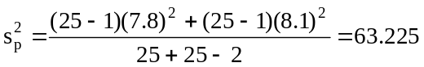 and 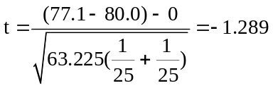
We will use the α = 0.05 level of significance in carrying out the test. For a right-tail area of
0.05/2 = 0.025 and d.f. = (n₁ + n₂ - 2) = (25 + 25 - 2) = 48, the critical values are t = -2.011
and t = 2.011. The decision rule is "Reject H₀ if the calculated t < -2.011 or > 2.011, otherwise
do not reject." Since the calculated test statistic falls in the nonrejection region, do not reject H₀.
At the 0.05 level, it appears that the two videotapes could be equally effective. The observed difference between the videotapes' means is judged to have been due to chance. Using the t table with
d.f. = 48, P(t ≤ -1.289) is between 0.05 and 0.10. Therefore, p-value = 2P(t ≤ -1.289) is between 0.10
and 0.20.

Given the summary data, we can also carry out this pooled-variances t-test using the Test Statistics workbook that accompanies Data Analysis Plus. This procedure requires that we first square the two sample standard deviations (7.8 and 8.1) to obtain the sample variances (60.84 and 65.61). The results are shown below. For this two-tail test, the p-value (0.2034) is not less than the 0.05 level of significance being used to reach a conclusion, so the null hypothesis is not rejected. For a true null hypothesis, there is a 0.2034 probability that this much of a difference between the sample means could occur by chance.
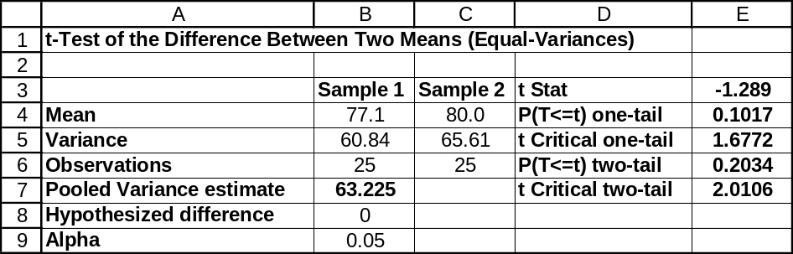

11.3 p/a/m The null and alternative hypotheses are:
H₀: μ₁ = μ₂ , or μ₁ - μ₂ = 0 (average number of TV hours for seniors and sophomores are equal )
H₁: μ₁ ≠ μ₂ , or μ₁ - μ₂ ≠ 0 (average number of TV hours for seniors and sophomores are not equal)
₁ and ₂ are the mean number of TV hours for seniors and sophomores.
The pooled estimate of the common variance, and the test statistic, t, are:
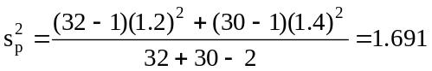 and 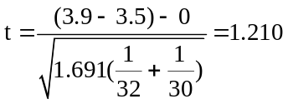
We will use the α = 0.05 level of significance in carrying out the test. For a right-tail area of
0.05/2 = 0.025 and d.f. = (n₁ + n₂ - 2) = (32 + 30 - 2) = 60, the critical values are t = -2.000 and
t = 2.000. The decision rule is "Reject H₀ if the calculated t < -2.000 or > 2.000, otherwise do not reject." Since the calculated test statistic falls in the nonrejection region, do not reject H₀.
At the 0.05 level, it appears that the average number of TV hours per week could be equal for high school seniors and sophomores. The observed difference between the groups' means is judged to have been due to chance. Using the t table with d.f. = 60, P(t ≥ 1.210) is greater than 0.10. Therefore, p-value is greater than 0.20.

Given the summary data, we can also carry out this pooled-variances t-test using the Test Statistics workbook that accompanies Data Analysis Plus. This procedure requires that we first square the two sample standard deviations (1.2 and 1.4) to obtain the sample variances (1.44 and 1.96). The results are shown below. For this two-tail test, the p-value (0.2309) is not less than the 0.05 level of significance being used to reach a conclusion, so the null hypothesis is not rejected. For a true null hypothesis, there is a 0.2309 probability that this much of a difference between the sample means could occur by chance.
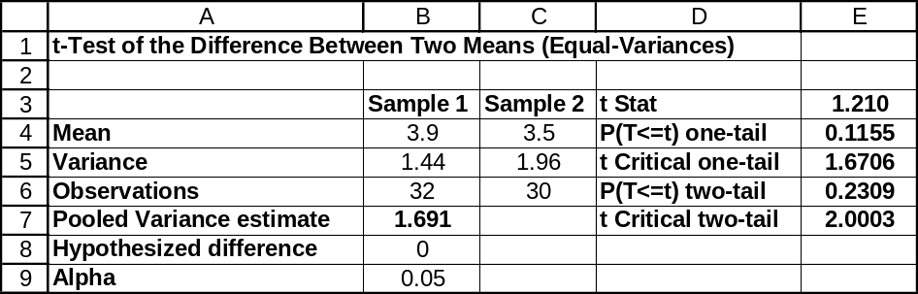

11.4 p/a/m The null and alternative hypotheses are:
H₀: μ₁ = μ₂ , or μ₁ - μ₂ = 0 (the two routes take the same amount of time)
H₁: μ₁ ≠ μ₂ , or μ₁ - μ₂ ≠ 0 (the two routes do not take the same amount of time)
₁ and ₂ are the mean number of minutes for sample trips taking routes A and B.
The pooled estimate of the common variance, and the test statistic, t, are:
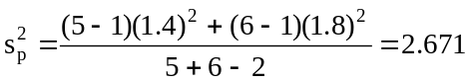 and 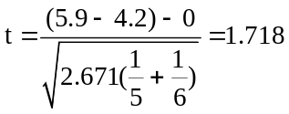
We will use the α = 0.10 level of significance in carrying out the test. For a right-tail area of 0.10/2 = 0.05 and d.f. = (n₁ + n₂ - 2) = (5 + 6 - 2) = 9, the critical values are t = -1.833 and t = 1.833. The decision rule is "Reject H₀ if the calculated t < -1.833 or > 1.833, otherwise do not reject." Since the calculated test statistic falls in the nonrejection region, do not reject H₀. At the 0.10 level, the two routes do not appear to be significantly different in travel time. The observed difference between the routes' means is judged to have been due to chance.
Given the summary data, we can also carry out this pooled-variances t-test using the Test Statistics workbook that accompanies Data Analysis Plus. This procedure requires that we first square the two sample standard deviations (1.4 and 1.8) to obtain the sample variances (1.96 and 3.24). The Estimators workbook that accompanies Data Analysis Plus has been used to obtain the 90% confidence interval for (μ₁ - μ₂). For this two-tail test, the p-value (0.1200) is not < the 0.10 level of significance being used to reach a conclusion, so H₀ is not rejected.
For a true H₀, there is a 0.1200 probability that this much of a difference between the sample means could occur by chance. The 90% confidence interval for (μ₁ - μ₂) is from -0.114 to 3.514. This interval includes 0, so the actual difference between the means could be 0. The conclusion using the 90% confidence interval is consistent with the results of the two-tail test at the 0.10 level of significance.
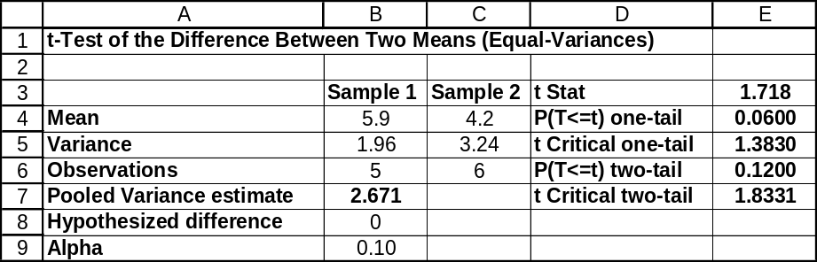

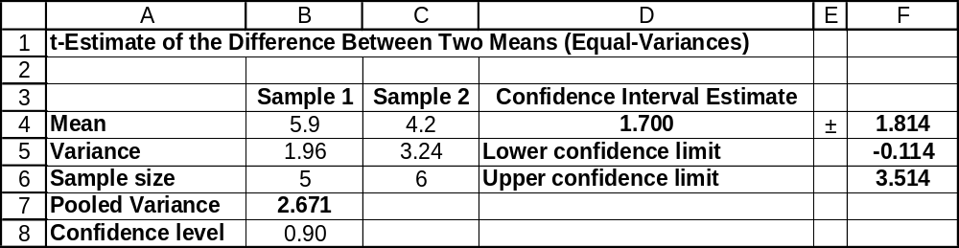

11.5 p/a/m The null and alternative hypotheses are:
H₀: μ₁ ≥ μ₂ , or μ₁ - μ₂ ≥ 0 (the experimental booklet is not better than the standard one)
H₁: μ₁ < μ₂ , or μ₁ - μ₂ < 0 (the experimental booklet is better than the standard one)
₁ and ₂ are the mean exam scores for the standard version and the one claimed to be superior.
The pooled estimate of the common variance, and the test statistic, t, are:
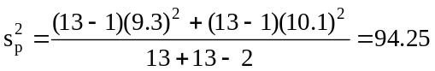 and 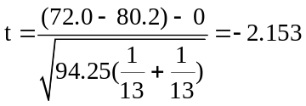
We will use the α = 0.05 level of significance. For a left-tail area of 0.05 and d.f. = (n₁ + n₂ - 2) =
(13 + 13 - 2) = 24, the critical value is t = -1.711. The decision rule is: "Reject H₀ if the calculated
t < -1.711, otherwise do not reject." Since the calculated test statistic falls in the rejection region,
reject H₀. At the 0.05 level, the experimental booklet appears to be better than the standard version.

Given the summary data, we can also carry out this pooled-variances t-test using the Test Statistics workbook that accompanies Data Analysis Plus. This procedure requires that we first square the two sample standard deviations (9.3 and 10.1) to obtain the sample variances (86.49 and 102.01). For this left-tail test, the p-value (0.0208) is less than the 0.05 level of significance being used to reach a conclusion, so the null hypothesis is rejected. For a true null hypothesis, there is only a 0.0208 probability that the difference between the sample means (72.0 - 80.2) would be this much less than 0 just by chance.
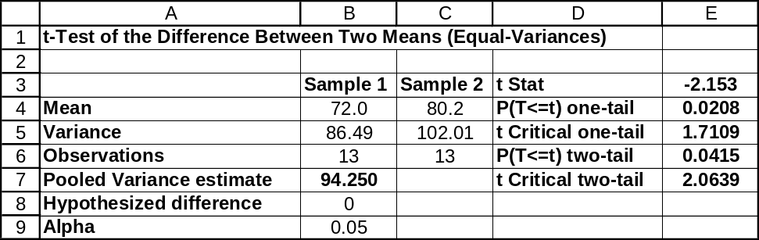

11.6 p/a/m The null and alternative hypotheses are:
H₀: μ₁ = μ₂ , or μ₁ - μ₂ = 0 (the two account managers have equal means)
H₁: μ₁ ≠ μ₂ , or μ₁ - μ₂ ≠ 0 (the two account managers do not have equal means)
₁ and ₂ are the mean transactions for customers serviced by the two managers.
The pooled estimate of the common variance, and the test statistic, t, are:
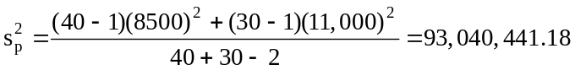, 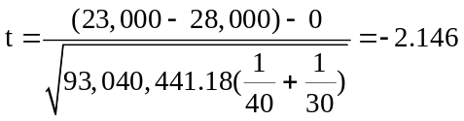
We will use the α = 0.05 level of significance. For a right-tail area of 0.05/2 = 0.025 and d.f. =
(n₁ + n₂ - 2) = (40 + 30 - 2) = 68, the critical values are t = -1.995 and t = 1.995. The decision rule is: "Reject H₀ if the calculated t < -1.995 or > 1.995, otherwise do not reject." Since the calculated test statistic falls in the rejection region, reject H₀. At the 0.05 level, it appears the population mean transactions are not equal for customers serviced by the two account managers. Using the t table with
d.f. = 68, P(t ≤ -2.146) is between 0.01 and 0.025. Therefore, p-value = 2P(t ≤ -2.146) is between 0.02 and 0.05.

Given the summary data, we can also carry out this pooled-variances t-test using the Test Statistics workbook that accompanies Data Analysis Plus. This procedure requires that we first square the two sample standard deviations (8500 and 11,000) to obtain the sample variances (72,250,000 and 121,000,000). The Estimators workbook that accompanies Data Analysis Plus has been used to obtain the 95% confidence interval for (μ₁ - μ₂). For this two-tail test, the p-value (0.0354) is less than the 0.05 level of significance being used to reach a conclusion, so H₀ is rejected. For a true H₀, there is a 0.0354 probability that this much of a difference between the sample means could occur by chance. The 95% confidence interval for (μ₁ - μ₂) is from -$9648.8 to -$351.2. This interval does not include 0, so we conclude that (μ₁ - μ₂) must be some value other than 0. The conclusion using the 95% confidence interval is consistent with the results of the two-tail hypothesis test at the 0.05 level of significance.
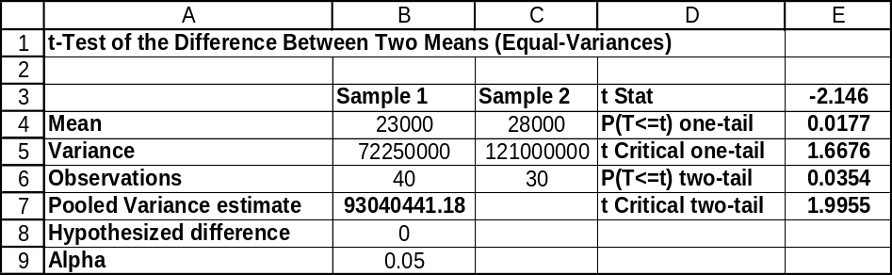

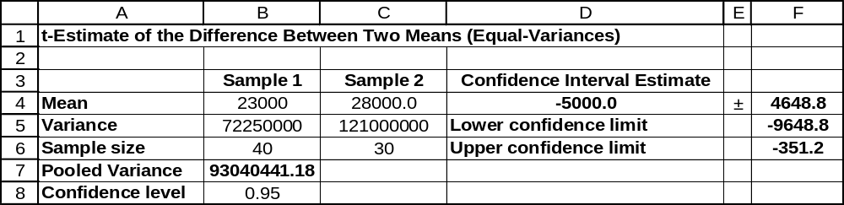

11.7 p/a/m The null and alternative hypotheses are:
H₀: μ₁ = μ₂ , or μ₁ - μ₂ = 0 (the average dexterity scores are equal for the 2 shifts)
H₁: μ₁ ≠ μ₂ , or μ₁ - μ₂ ≠ 0 (the average dexterity scores are not equal for the 2 shifts)
₁ and ₂ are the average dexterity scores for workers on the day and night shifts.
The pooled estimate of the common variance, and the test statistic, t, are:
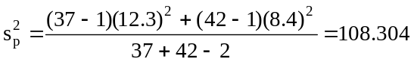 and 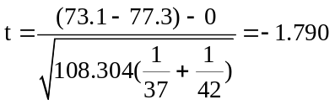
We will use the α = 0.05 level of significance. For a right-tail area of 0.05/2 = 0.025 and d.f. =
(n₁ + n₂ - 2) = (37 + 42 - 2) = 77, the critical values are t = -1.991 and t = 1.991. The decision rule is: "Reject H₀ if the calculated t < -1.991 or > 1.991, otherwise do not reject." Since the calculated test statistic falls in the nonrejection region, do not reject H₀. At the 0.05 level, it appears that the average dexterity scores for the two shifts are equal. The observed difference between the shifts' means is judged to have been due to chance. Using the t table with d.f. = 77, P(t ≤ -1.790) is between 0.025 and 0.05. Therefore, p-value = 2P(t ≤ -1.790) is between 0.05 and 0.10.

Given the summary data, we can also carry out this pooled-variances t-test using the Test Statistics workbook that accompanies Data Analysis Plus. This procedure requires that we first square the two sample standard deviations (12.3 and 8.4) to obtain the sample variances (151.29 and 70.56).
The Estimators workbook that accompanies Data Analysis Plus has been used to obtain the 95% confidence interval for (μ₁ - μ₂). For this two-tail test, the p-value (0.0774) is not less than the 0.05 level of significance being used to reach a conclusion, so H₀ is not rejected. For a true H₀, there is a 0.0774 probability that this much of a difference between the sample means could occur by chance.
The 95% confidence interval for (μ₁ - μ₂) is from -8.872 to 0.472. This interval includes 0, so we conclude that (μ₁ - μ₂) could be 0. The conclusion using the 95% confidence interval is consistent with the results of the two-tail hypothesis test at the 0.05 level of significance
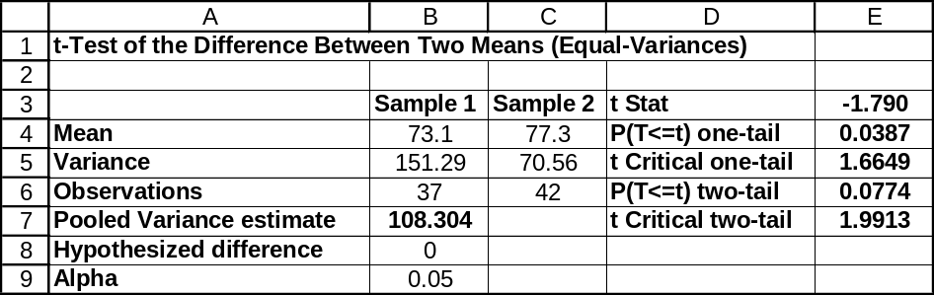
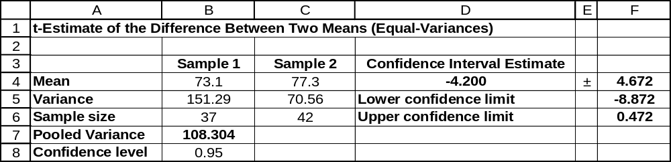

11.8 p/a/m The null and alternative hypotheses are:
H₀: μ₁ ≤ μ₂ , or μ₁ - μ₂ ≤ 0 (the time for serving female guests is no greater than that for males.)
H₁: μ₁ > μ₂ , or μ₁ - μ₂ > 0 (the time for serving female guests is greater than that for males.)
₁ and ₂ are the mean service times observed for females and males, respectively.
The pooled estimate of the common variance, and the test statistic, t, are:
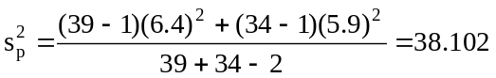 and 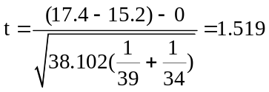
We will use the α = 0.05 level of significance. For a right-tail area of 0.05 and d.f. = (n₁ + n₂ - 2) =
(39 + 34 - 2) = 71, the critical value is t = 1.667. The decision rule is: "Reject H₀ if the calculated
t > 1.667, otherwise do not reject." Since the calculated test statistic does not fall in the rejection region, we are unable to reject H₀. At the 0.05 level, we conclude that the mean time for serving female guests is no greater than that for serving male guests. Using the t table with d.f. = 71, P(t ≥ 1.519) is between 0.10 and 0.05. Based on our t table, we can say that the p-value for the test is between 0.10 and 0.05.

Given the summary data, we can also carry out this pooled-variances t-test using the Test Statistics workbook that accompanies Data Analysis Plus. This procedure requires that we first square the two sample standard deviations (6.4 and 5.9) to obtain the sample variances (40.96 and 34.81). For this right-tail test, the p-value (0.0666) is not less than the 0.05 level of significance being used to reach a conclusion, so the null hypothesis is not rejected. For a true null hypothesis, there is a 0.0666 probability that the difference between the sample means (17.4 - 15.2) would be this much greater than 0 just by chance.
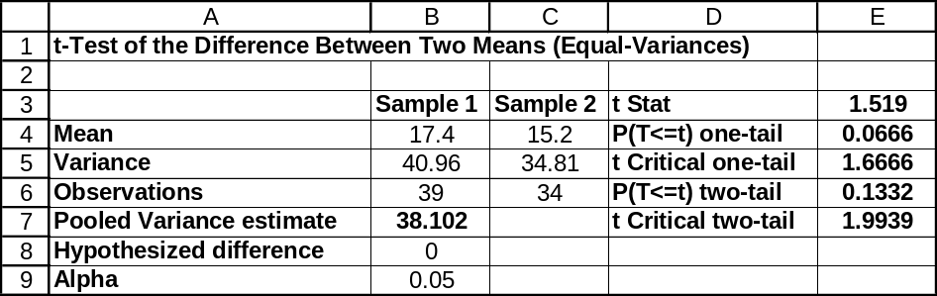

11.9 p/a/m The null and alternative hypotheses are:
H₀: μ₁ = μ₂ , or μ₁ - μ₂ = 0 (the mean times for business/financial news are the same)
H₁: μ₁ ≠ μ₂ , or μ₁ - μ₂ ≠ 0 (the mean times are not the same for the two channels.)
₁ and ₂ are the average times for channel 2 and channel 4, respectively.
After computing the mean and standard deviation for each sample, the pooled estimate of the common variance and the test statistic, t, are:
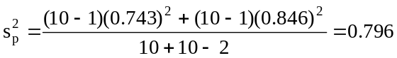 and 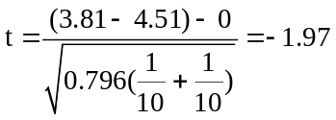
We will use the α = 0.10 level of significance. For a right-tail area of 0.10/2 = 0.05 and d.f. =
(n₁ + n₂ - 2) = (10 + 10 - 2) = 18, the critical values are t = -1.734 and t = 1.734. The decision rule is: "Reject H₀ if the calculated t < -1.734 or > 1.734, otherwise do not reject." Since the calculated test statistic falls in the rejection region, we reject H₀. At the 0.10 level, it appears that the mean times devoted to business/financial news are not equal for the two channels. Using the t table with d.f. = 18,
P(t ≤ -1.97) is between 0.05 and 0.025. Therefore, p-value = 2P(t ≤ -1.97) is between 0.10 and 0.05.
These results can also be obtained using Minitab. The 90% confidence interval for (μ₁ - μ₂) is shown as
(-1.318 to -0.082), an interval that does not include a difference of zero. This is consistent with the results of the two-tail hypothesis test.

Two-Sample T-Test and CI: chan2, chan4

Two-sample T for chan2 vs chan4

N Mean StDev SE Mean
chan2 10 3.810 0.743 0.23
chan4 10 4.510 0.846 0.27

Difference = mu chan2 - mu chan4
Estimate for difference: -0.700
90% CI for difference: (-1.318, -0.082)
T-Test of difference = 0 (vs not =): T-Value = -1.97 P-Value = 0.065 DF = 18
Both use Pooled StDev = 0.796

11.10 p/a/m If we are using pocket calculator and tables, we must first determine the mean and variance for each sample. They are as shown below:
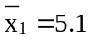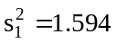
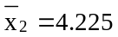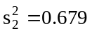
The null and alternative hypotheses are:
H₀: μ₁ ≤ μ₂ , or μ₁ - μ₂ ≤ 0 (the new battery is not better than the old one)
H₁: μ₁ > μ₂ , or μ₁ - μ₂ > 0 (the new battery is better than the old one)
₁ and ₂ are the mean hours of playing time for the new and old battery types.
The pooled estimate of the common variance, and the test statistic, t, are:
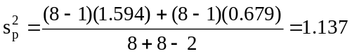 and 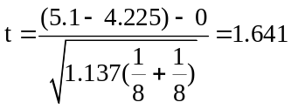
We will use the α = 0.05 level of significance. For a right-tail area of 0.05 and d.f. = (n₁ + n₂ - 2)
= (8 + 8 - 2) = 14, the critical value is t = 1.761. The decision rule is "Reject H₀ if the calculated
t > 1.761, otherwise do not reject." Since the calculated test statistic falls in the nonrejection region,
do not reject H₀. At the 0.05 level, it appears that the new battery is not better than the old design.
The observed difference between the batteries' means is judged to have been due to chance.
Using the t table with d.f. = 14, p-value = P(t ≥ 1.641) is between 0.05 and 0.10. The following Minitab printout corresponds to the preceding solution:

Two-Sample T-Test and CI: New, Old

Two-sample T for New vs Old

N Mean StDev SE Mean
New 8 5.10 1.26 0.45
Old 8 4.225 0.824 0.29

Difference = mu New - mu Old
Estimate for difference: 0.875
95% lower bound for difference: -0.064
T-Test of difference = 0 (vs >): T-Value = 1.64 P-Value = 0.061 DF = 14
Both use Pooled StDev = 1.07

11.11 p/a/m The null and alternative hypotheses are:
H₀: μ₁ ≥ μ₂ , or μ₁ - μ₂ ≥ 0 (FoodFarm's peanut butter does not contain less fat)
H₁: μ₁ < μ₂ , or μ₁ - μ₂ < 0 (FoodFarm's peanut butter does contain less fat)
₁ and ₂ are the mean fat contents for FoodFarm's and a major competitor's peanut butter.
The pooled estimate of the common variance, and the test statistic, t, are:
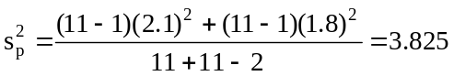 and 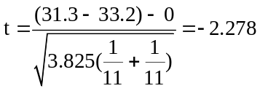
We will use the α = 0.05 level of significance in carrying out the test. For a left-tail area of 0.05 and
d.f. = (n₁ + n₂ - 2) = (11+ 11 - 2) = 20, the critical value is t = -1.725. The decision rule is "Reject H₀ if the calculated t < -1.725, otherwise do not reject." Since the calculated test statistic falls in the rejection region, reject H₀. At the 0.05 level, it appears that FoodFarm's claim their peanut butter contains less fat on the average could be valid. Using the t table with d.f. = 20, p-value = P(t ≤ -2.278) is between 0.01 and 0.025. Based on the summary statistics, Excel worksheet template tmt2pool was used in generating the following printout corresponding to this solution:
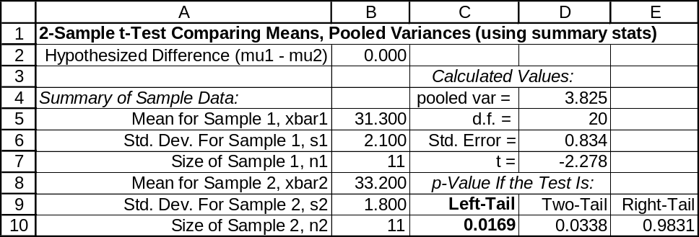

11.12 p/c/m The null and alternative hypotheses are:
H₀: μ₁ ≥ μ₂ , or μ₁ - μ₂ ≥ 0 (the most-problems doctors are not younger than the least-problems doctors)
H₁: μ₁ < μ₂ , or μ₁ - μ₂ < 0 (the most-problems doctors are younger)
Using Minitab, we obtain the printout below. For this left-tail test, the p-value (to three decimal places, 0.000) is less than the 0.01 level of significance being used to reach a conclusion, so H₀ is rejected.
For a true H₀, the probability is virtually zero that the sample mean age of the most-problems doctors would be this much less than that of the least-problems doctors just by chance.

Two-Sample T-Test and CI: Age_Most, Age_Least

Two-sample T for Age_Most vs Age_Least

N Mean StDev SE Mean
Age_Most 25 41.00 4.40 0.88
Age_Least 21 46.00 4.86 1.1

Difference = mu (Age_Most) - mu (Age_Least)
Estimate for difference: -5.00
95% upper bound for difference: -2.71
T-Test of difference = 0 (vs <): T-Value = -3.66 P-Value = 0.000 DF = 44
Both use Pooled StDev = 4.6122

11.13 p/c/m The null and alternative hypotheses are:
H₀: μ₁ ≤ μ₂ , or μ₁ - μ₂ ≤ 0 (the “rolled” bats are no faster than the standard bats)
H₁: μ₁ > μ₂ , or μ₁ - μ₂ > 0 (the “rolled” bats are faster)
Using Minitab, we obtain the printout below. For this right-tail test, the p-value (0.031) is less than the 0.05 level of significance being used to reach a conclusion, so H₀ is rejected.
We conclude that the “rolled” bats are faster in terms of the speed with which a pitch is returned. For a true H₀, the probability is just 0.031 that the sample mean for the “rolled” bats would be this much greater than that for the regulation bats just by chance.

Two-Sample T-Test and CI: Rolled, Regulation

Two-sample T for Rolled vs Regulation

N Mean StDev SE Mean
Rolled 105 91.57 7.88 0.77
Regulation 105 89.57 7.54 0.74

Difference = mu (Rolled) - mu (Regulation)
Estimate for difference: 2.00
95% lower bound for difference: 0.24
T-Test of difference = 0 (vs >): T-Value = 1.88 P-Value = 0.031 DF = 208
Both use Pooled StDev = 7.7116

11.14 p/c/m The null and alternative hypotheses are:
H₀: μ₁ = μ₂ , or μ₁ - μ₂ = 0 (men and women have the same number of Facebook “friends”)
H₁: μ₁ ≠ μ₂ , or μ₁ - μ₂ ≠ 0 (men and women do not have the same number of Facebook “friends)
Using Minitab, we obtain the printout below. For this two-tail test, the p-value (0.071) is not less than the 0.05 level of significance being used to reach a conclusion, so H₀ is not rejected. We conclude that men and women could have the same mean number of Facebook “friends”. For a true H₀, the probability is 0.071 that the difference between the sample means would be this great just by chance.

Two-Sample T-Test and CI: Males, Females

Two-sample T for Males vs Females

N Mean StDev SE Mean
Males 25 116.4 22.6 4.5
Females 25 128.0 21.8 4.4

Difference = mu (Males) - mu (Females)
Estimate for difference: -11.60
95% CI for difference: (-24.23, 1.03)
T-Test of difference = 0 (vs not =): T-Value = -1.85 P-Value = 0.071 DF = 48
Both use Pooled StDev = 22.2079

11.15 p/c/m As shown in the solution to exercise 11.14, the 95% confidence interval for (μ₁ - μ₂)
is from -24.23 to 1.03. Because this interval includes 0, we conclude (μ₁ - μ₂) could be 0.
The conclusion using the 95% confidence interval is consistent with the result of the two-tail hypothesis test at the 0.05 level of significance.

11.16 p/c/m The null and alternative hypotheses are:
H₀: μ₁ = μ₂ , or μ₁ - μ₂ = 0 and H₁: μ₁ ≠ μ₂ , or μ₁ - μ₂ ≠ 0
Using Minitab, we obtain the printout below. For this two-tail test, the p-value (0.107) is not less than the 0.05 level of significance being used to reach a conclusion, so H₀ is not rejected. We conclude that the two bearing designs do not differ in hardness. For a true H₀, the probability is 0.107 that the difference between the sample means would be this great just by chance.

Two-Sample T-Test and CI: Sample1, Sample2

Two-sample T for Sample1 vs Sample2

N Mean StDev SE Mean
Sample1 9 151.9 18.6 6.2
Sample2 10 138.0 17.1 5.4

Difference = mu Sample1 - mu Sample2
Estimate for difference: 13.93
95% CI for difference: (-3.33, 31.20)
T-Test of difference = 0 (vs not =): T-Value = 1.70 P-Value = 0.107 DF = 17
Both use Pooled StDev = 17.8

11.17 p/c/m As shown in the solution to exercise 11.16, the 95% confidence interval for (μ₁ - μ₂) is from -3.33 to 31.20. This interval includes 0, so we conclude that (μ₁ - μ₂) could be 0. The conclusion using the 95% confidence interval is consistent with the result of the two-tail hypothesis test at the 0.05 level.

11.18 c/a/m The null and alternative hypotheses are:
H₀: μ₁ = μ₂ , or μ₁ - μ₂ = 0 and H₁: μ₁ ≠ μ₂ , or μ₁ - μ₂ ≠ 0
Assuming σ₁ ≠ σ₂, we use the unequal-variances t-test and the computer. Hand calculations for the
t statistic and d.f. can be carried out as shown below.
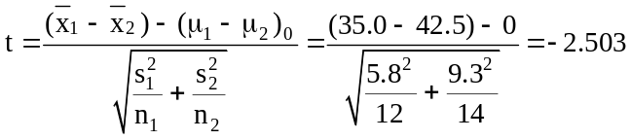
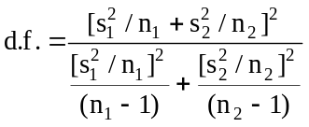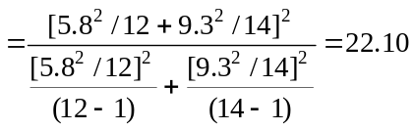
Using the tmt2uneq Excel worksheet template, the p-value for this two-tail test (0.0203) is less than the 0.05 level of significance used to reach a conclusion, so H₀ is rejected. We conclude that the population means are not equal. For a true H₀, the probability is 0.0203 that the difference between the sample means would be this great just by chance.
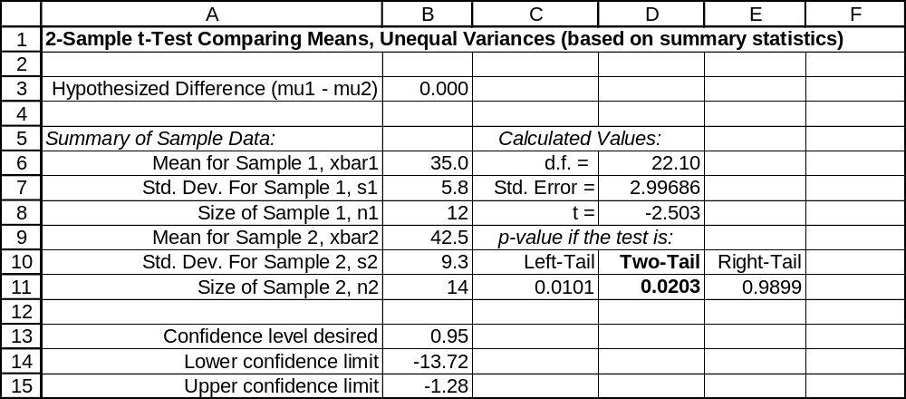

11.19 c/a/m The null and alternative hypotheses are:
H₀: μ₁ ≥ μ₂ , or μ₁ - μ₂ ≥ 0 and H₁: μ₁ < μ₂ , or μ₁ - μ₂ < 0
Assuming σ₁ ≠ σ₂, we will use the unequal-variances t-test and the computer.
Hand calculations for the t statistic and d.f. can be carried out as shown below.
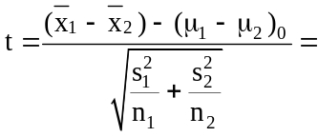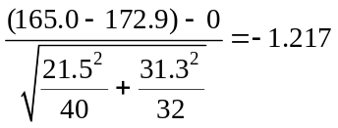
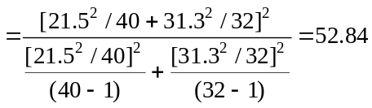
We will use the Test Statistics workbook that accompanies Data Analysis Plus. This procedure requires that we first square the two sample standard deviations (21.5 and 31.3) to obtain the sample variances (462.25 and 979.69). The p-value for this left-tail test (0.1146) is not less than the 0.10 level of significance used to reach a conclusion, so H₀ is not rejected. We conclude that the mean for population one could be at least as large as that for population two. For a true H₀, the probability is 0.1146 that the mean for sample one would be this much less than that for sample two just by chance.
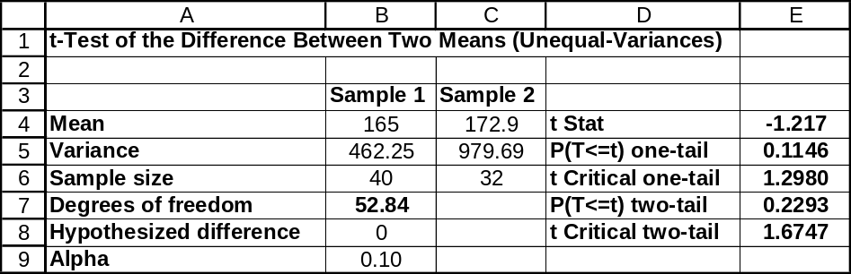

11.20 c/a/m The null and alternative hypotheses are:
H₀: μ₁ ≤ μ₂ , or μ₁ - μ₂ ≤ 0 and H₁: μ₁ > μ₂ , or μ₁ - μ₂ > 0
Assuming σ₁ ≠ σ₂, we will use the unequal-variances t-test and the computer.
Hand calculations for the t statistic and d.f. can be carried out as shown below.
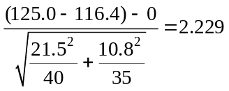
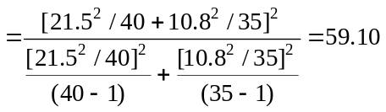
Using the tmt2uneq Excel worksheet template, the p-value for this right-tail test (0.0148) is less than the 0.025 level of significance used to reach a conclusion, so H₀ is rejected. We conclude that the mean of population 1 is greater than that of population 2. For a true H₀, the probability is only 0.0148 that the mean of sample 1 would be this much larger than the mean of sample 2 just by chance.
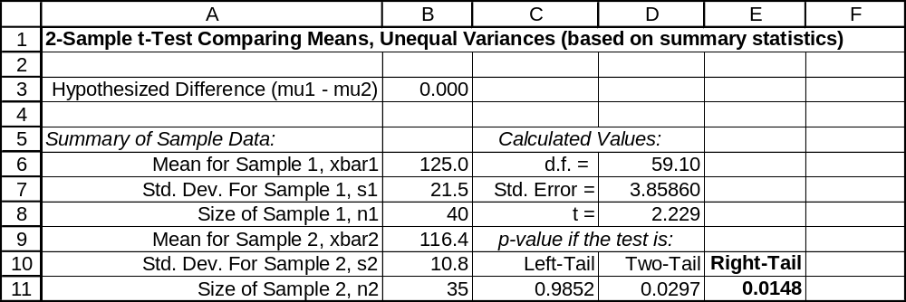

11.21 p/a/m The null and alternative hypotheses are:
H₀: μ₁ = μ₂ , or μ₁ - μ₂ = 0 and H₁: μ₁ ≠ μ₂ , or μ₁ - μ₂ ≠ 0
Assuming σ₁ ≠ σ₂, we will use the unequal-variances t-test and the computer.
Hand calculations for the t statistic and d.f. can be carried out as shown below.
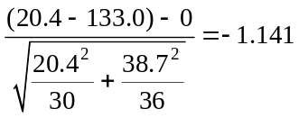
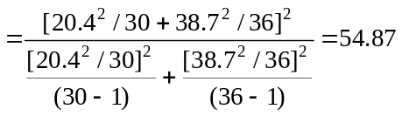
With df = 54.87 (rounded to df = 55 for reference to our t table) and a two-tail test at the 0.05 level of significance, the critical values of t are t = -2.004 and t = +2.004. The calculated t = -1.141 lies within these critical values and we are not able to reject the null hypothesis of equal population means.
Using the t table, we see that the calculated t = -1.141 is even within the critical values of t for a two-tail test at the 0.20 level of significance (-1.297 and +1.297), so p-value is > 0.20.
Using the tmt2uneq Excel worksheet template, the p-value for this two-tail test (0.2588) is not less than the 0.05 level of significance used to reach a conclusion, so H₀ is not rejected. We conclude that the population means could be equal. The 95% confidence interval for the difference between the population means is shown below as (-23.43, 6.43). The interval includes a difference of 0, and this is consistent with the findings of our two-tail test at the 0.05 level.
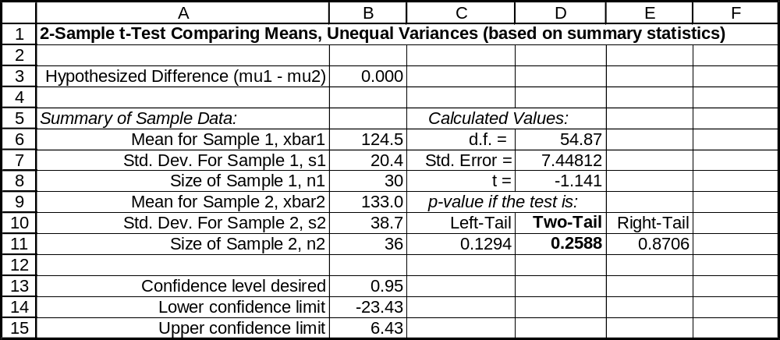

11.22 p/a/m The null and alternative hypotheses are:
H₀: μ₁ ≤ μ₂ , or μ₁ - μ₂ ≤ 0 and H₁: μ₁ > μ₂ , or μ₁ - μ₂ > 0
Assuming σ₁ ≠ σ₂, we use the unequal-variances t-test and the computer. Hand calculations for the t statistic and d.f. can be carried out as shown below.
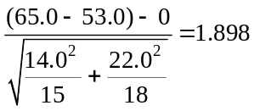
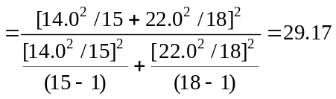
With df = 29.17 (rounded to df = 29 for reference to our t table) and a right-tail test at the 0.05 level of significance, the critical value of t is t = 1.699. The calculated t = 1.898 exceeds the critical value and we reject the null hypothesis. Using the t table, we see that the calculated t = 1.898 is greater than the critical value for the 0.05 level (1.699), but is not greater than the critical value for the 0.025 level (2.045), so the p-value for the test is between 0.05 and 0.025.
We will also use the Test Statistics workbook that accompanies Data Analysis Plus. This procedure requires that we first square the two sample standard deviations (14 and 22) to obtain the sample variances (196 and 484). The p-value for this right-tail test is 0.0338. This is less than the 0.05 level of significance used to reach a conclusion, so H₀ is rejected. We conclude that the new adhesive is superior to the old. For a true H₀, the probability is only 0.0338 that the mean for the new-adhesive sample would be this much greater than that for the conventional-adhesive sample just by chance.
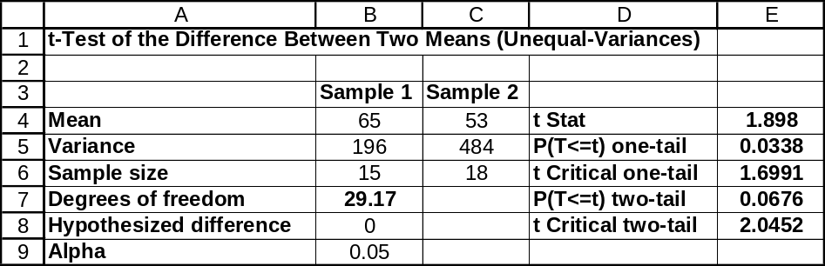

11.23 p/a/m The null and alternative hypotheses are:
H₀: μ₁ = μ₂ , or μ₁ - μ₂ = 0 and H₁: μ₁ ≠ μ₂ , or μ₁ - μ₂ ≠ 0
Assuming σ₁ ≠ σ₂, we use the unequal-variances t-test and the computer. Hand calculations for the
t statistic and d.f. can be carried out as shown below.
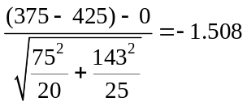
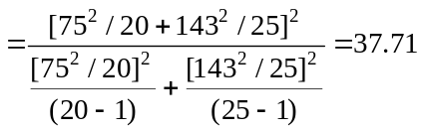
With df = 37.71 (rounded to df = 38 for reference to our t table) and a two-tail test at the 0.05 level of significance, the critical values of t are t = -2.024 and t = +2.024. The calculated t = -1.508 lies within these critical values and we are not able to reject the null hypothesis of equal population means.
Using the t table, the most accurate statement we could make about the p-value for the test is that it is between 0.10 and 0.20.
Given the summary data, we can also carry out this unequal-variances t-test using the Test Statistics workbook that accompanies Data Analysis Plus. This procedure requires that we first square the two sample standard deviations (75 and 143) to obtain the sample variances (5625 and 20,449).
The Estimators workbook that accompanies Data Analysis Plus has been used to obtain the 95% confidence interval for (μ₁ - μ₂). For this two-tail test, the p-value (0.1400) is not less than the 0.05 level of significance being used to reach a conclusion, so H₀ is not rejected. For a true H₀, there is a 0.1400 probability that this much of a difference between the sample means could occur by chance. The 95% confidence interval for (μ₁ - μ₂) is from -$117.18 to $17.18. This interval includes 0, so we conclude that (μ₁ - μ₂) could be 0. The conclusion using the 95% confidence interval is consistent with the result of the two-tail hypothesis test at the 0.05 level of significance.
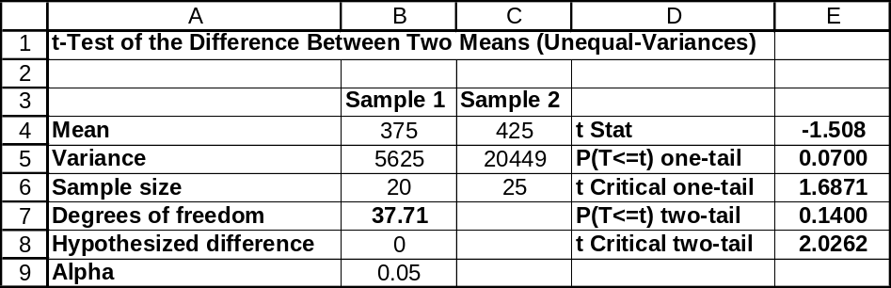

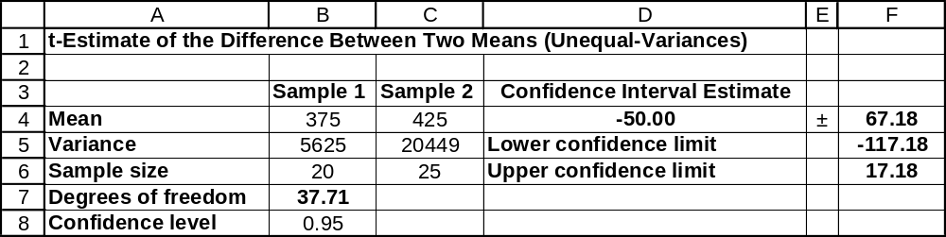

11.24 p/a/m The null and alternative hypotheses are:
H₀: μ₁ = μ₂ , or μ₁ - μ₂ = 0 and H₁: μ₁ ≠ μ₂ , or μ₁ - μ₂ ≠ 0
Assuming σ₁ ≠ σ₂, we will carry out this unequal-variances t-test using the Test Statistics workbook that accompanies Data Analysis Plus. This procedure requires that we first square the two sample standard deviations (50 and 28) to obtain the sample variances (2500 and 784). The Estimators workbook that accompanies Data Analysis Plus has been used to obtain the 95% confidence interval for (μ₁ - μ₂). For this two-tail test, the p-value (0.0597) is less than the 0.10 level of significance being used to reach a conclusion, so H₀ is rejected. For a true H₀, there is a 0.0597 probability that this much of a difference between the sample means could occur by chance. The 90% confidence interval for
(μ₁ - μ₂) is from 2.47 to 35.53 milliseconds. This interval does not include 0, so we conclude that
(μ₁ - μ₂) could not be 0. The conclusion using the 90% confidence interval is consistent with the result of the two-tail hypothesis test at the 0.10 level of significance.
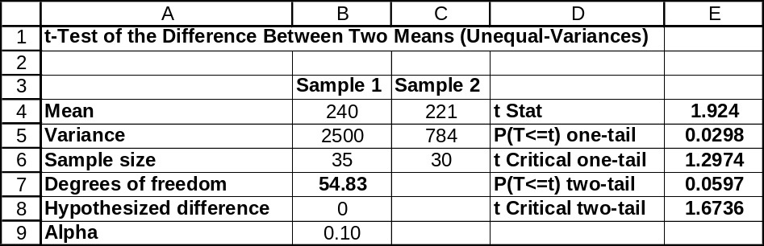

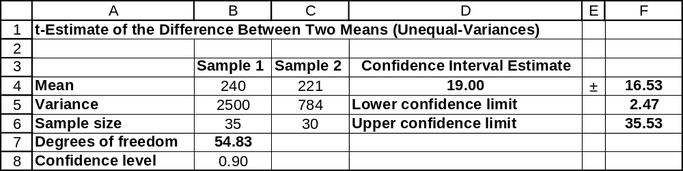

11.25 p/a/d The null and alternative hypotheses are:
H₀: μ₁ - μ₂ = -2.0 and H₁: μ₁ - μ₂ ≠ -2.0
Assuming σ₁ ≠ σ₂, we will carry out this unequal-variances t-test using the Test Statistics workbook that accompanies Data Analysis Plus. This procedure requires that we first square the two sample standard deviations (0.6 and 0.9) to obtain the sample variances (0.36 and 0.81). The Estimators workbook that accompanies Data Analysis Plus has been used to obtain the 95% confidence interval for (μ₁ - μ₂).
Note that the hypothesized difference in this exercise is not zero. For this two-tail test, the
p-value (0.0748) is not less than the 0.05 level of significance being used to reach a conclusion, so H₀ is not rejected. For a true H₀, there is a 0.0748 probability that the difference between the sample means could have been this far away from -0.2 visits per year by chance. The 95% confidence interval for
(μ₁ - μ₂) is from -2.03 to -1.37 visits per year. This interval includes -2.0, the hypothesized difference, so we conclude that (μ₁ - μ₂) could be -2.0 visits per year. The conclusion using the 95% confidence interval is consistent with the result of the two-tail hypothesis test at the 0.05 level of significance.
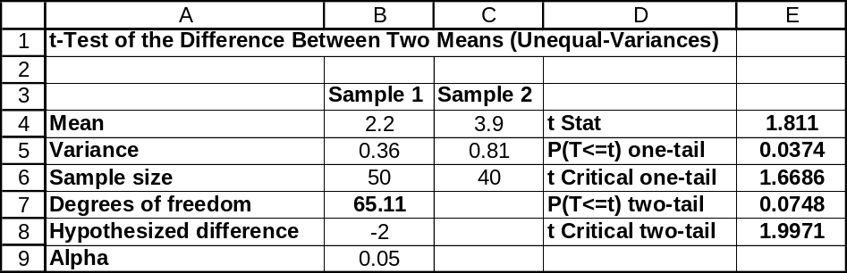

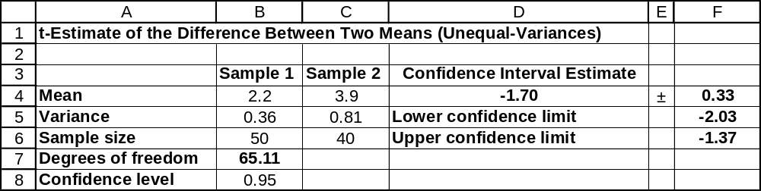

11.26 p/a/m The null and alternative hypotheses are:
H₀: μ₁ ≤ μ₂ , or μ₁ - μ₂ ≤ 0 and H₁: μ₁ > μ₂ , or μ₁ - μ₂ > 0
Given the summary data, we will carry out this unequal-variances t-test using the Test Statistics workbook that accompanies Data Analysis Plus. This procedure requires that we first square the two sample standard deviations (7.4 and 4.9) to obtain the sample variances (54.76 and 24.01).
The p-value for this right-tail test is 0.0130. This is less than the 0.025 level of significance used to reach a conclusion, so H₀ is rejected. We conclude that the new music is superior to the old. For a true H₀, the probability is only 0.0130 that the mean increase for the new-music sample would be this much greater than that for the standard-music sample just by chance.
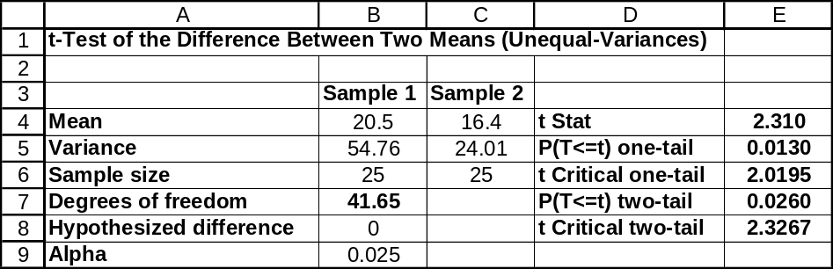
11.27 p/c/m The null and alternative hypotheses are:
H₀: μ₁ ≤ μ₂ , or μ₁ - μ₂ ≤ 0 and H₁: μ₁ > μ₂ , or μ₁ - μ₂ > 0
Assuming σ₁ ≠ σ₂, we use the unequal-variances t-test and Minitab. The printout is shown below.
The p-value for this right-tail test is, to three decimal places, 0.000. This is less than the 0.01 level of significance used to reach a conclusion, so H₀ is rejected. We conclude that the mean time spent shopping by women is greater than that by men. For a true H₀, the probability is virtually zero that the sample mean for women would be this much greater than that for men just by chance.

Two-Sample T-Test and CI: women, men

Two-sample T for women vs men

N Mean StDev SE Mean
women 15 19.10 5.36 1.4
men 14 12.70 3.28 0.88

Difference = mu women - mu men
Estimate for difference: 6.40
95% lower bound for difference: 3.59
T-Test of difference = 0 (vs >): T-Value = 3.91 P-Value = 0.000 DF = 23

11.28 p/c/m The null and alternative hypotheses are:
H₀: μ₁ = μ₂ , or μ₁ - μ₂ = 0 and H₁: μ₁ ≠ μ₂ , or μ₁ - μ₂ ≠ 0
Assuming σ₁ ≠ σ₂, we use the unequal-variances t-test and Minitab. The printout is shown below.
For this two-tail test, the p-value (0.079) is not less than the 0.05 level of significance being used to reach a conclusion, so H₀ is not rejected. We conclude that the two prototypes may not differ in terms of the price that potential buyers would expect to pay. For a true H₀, there is a 0.079 probability that this much of a difference between the sample means could occur by chance. The 95% confidence interval for
(μ₁ - μ₂) is from -$155.8 to $8.8.This interval includes 0, so we conclude that (μ₁ - μ₂) could be 0.
The conclusion using the 95% confidence interval is consistent with the result of the two-tail hypothesis test at the 0.05 level of significance.

Two-Sample T-Test and CI: ComputerA, ComputerB
Two-sample T for ComputerA vs ComputerB

N Mean StDev SE Mean
Computer 45 3049 228 34
Computer 40 3123 149 24

Difference = mu ComputerA - mu ComputerB
Estimate for difference: -73.5
95% CI for difference: (-155.8, 8.8)
T-Test of difference = 0 (vs not =): T-Value = -1.78 P-Value = 0.079 DF = 76

11.29 p/c/m The null and alternative hypotheses are:
H₀: μ₁ ≤ μ₂ , or μ₁ - μ₂ ≤ 0 and H₁: μ₁ > μ₂ , or μ₁ - μ₂ > 0
Assuming σ₁ ≠ σ₂, we use the unequal-variances t-test and Minitab. The printout is shown below.
The p-value for this right-tail test is 0.006. This is less than the 0.05 level of significance used to reach a conclusion, so H₀ is rejected. We conclude that the mean spending amount for Japanese visitors is greater than for British visitors. For a true H₀, the probability is 0.006 that the sample mean for Japanese visitors would be this much higher than that for British visitors just by chance.

Two-Sample T-Test and CI: Japan, England

Two-sample T for Japan vs England

N Mean StDev SE Mean
Japan 31 3120 803 144
England 34 2654 610 105

Difference = mu (Japan) - mu (England)
Estimate for difference: 466
95% lower bound for difference: 168
T-Test of difference = 0 (vs >): T-Value = 2.62 P-Value = 0.006 DF = 55

11.30 p/c/m The null and alternative hypotheses are:
H₀: μ₁ = μ₂ , or μ₁ - μ₂ = 0 and H₁: μ₁ ≠ μ₂ , or μ₁ - μ₂ ≠ 0
Assuming σ₁ ≠ σ₂, we use the unequal-variances t-test and Minitab. The printout is shown below.
For this two-tail test, the p-value (0.106) not is less than the 0.01 level of significance being used to reach a conclusion, so H₀ is not rejected. We conclude that average minutes per visit could be the same for the two online newspaper sites. For a true H₀, there is a 0.106 probability that this much of a difference between the sample means could occur by chance. The 99% confidence interval for (μ₁ - μ₂) is from
-0.739 to 3.139 minutes. Because this interval includes 0, we conclude that (μ₁ - μ₂) could be 0.
The conclusion using the 99% confidence interval is consistent with the result of the two-tail hypothesis test at the 0.01 level of significance.

Two-Sample T-Test and CI: usatoday, washpost

Two-sample T for usatoday vs washpost

N Mean StDev SE Mean
usatoday 50 12.20 4.61 0.65
washpost 50 11.00 2.36 0.33

Difference = mu (usatoday) - mu (washpost)
Estimate for difference: 1.200
99% CI for difference: (-0.739, 3.139)
T-Test of difference = 0 (vs not =): T-Value = 1.64 P-Value = 0.106 DF = 73

11.31 d/p/e When both sample sizes are greater than or equal to 30, it is appropriate to use the z-test as an approximation to the unequal-variances t-test when comparing the means of two independent samples.

11.32 c/a/m The null and alternative hypotheses are:
H₀: μ₁ = μ₂ , or μ₁ - μ₂ = 0 and H₁: μ₁ ≠ μ₂ , or μ₁ - μ₂ ≠ 0
The test statistic is: 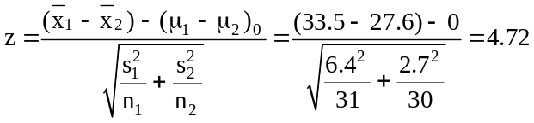
For a two-tail test at the 0.01 significance level, the critical values are z = -2.58 and z = 2.58.
The decision rule is: "Reject H₀ if the calculated z < -2.58 or > 2.58, otherwise do not reject." Since the calculated test statistic falls in the rejection region, reject H₀. At the 0.01 level, we can conclude that the population means are not equal.

11.33 c/a/m The null and alternative hypotheses are:
H₀: μ₁ ≤ μ₂ , or μ₁ - μ₂ ≤ 0 and H₁: μ₁ > μ₂ , or μ₁ - μ₂ > 0
The test statistic is: 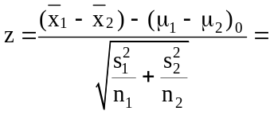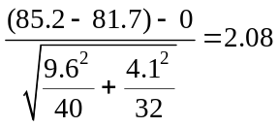
For a right-tail test at the 0.05 significance level, the critical value is z = 1.645. The decision rule is: "Reject H₀ if the calculated z > 1.645, otherwise do not reject." Since the calculated test statistic falls in the rejection region, reject H₀. At the 0.05 level, we can conclude that μ₁ is greater than μ₂.

11.34 c/a/m c/a/m The null and alternative hypotheses are:
H₀: μ₁ ≤ μ₂ , or μ₁ - μ₂ ≤ 0 and H₁: μ₁ > μ₂ , or μ₁ - μ₂ > 0
Using the tmz2test Excel worksheet template, the p-value for this right-tail test (0.0129) is less than the 0.025 level of significance used to reach a conclusion, so H₀ is rejected. Using the 0.025 level of significance, it appears that the mean for population 1 exceeds that for population 2.
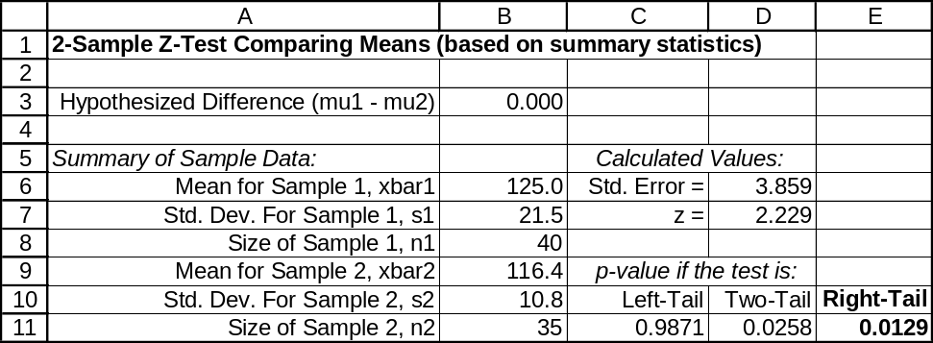

11.35 p/a/m The null and alternative hypotheses are:
H₀: μ₁ = μ₂ , or μ₁ - μ₂ = 0 and H₁: μ₁ ≠ μ₂ , or μ₁ - μ₂ ≠ 0
Using the tmz2test Excel worksheet template, the p-value for this two-tail test (0.2538) is not less than the 0.05 level of significance used to reach a conclusion, so H₀ is not rejected. We conclude that the population means could be equal. The 95% confidence interval for the difference between the population means is shown below as (-23.10, 6.10). The interval includes a difference of 0, and this is consistent with the findings of our two-tail test at the 0.05 level.
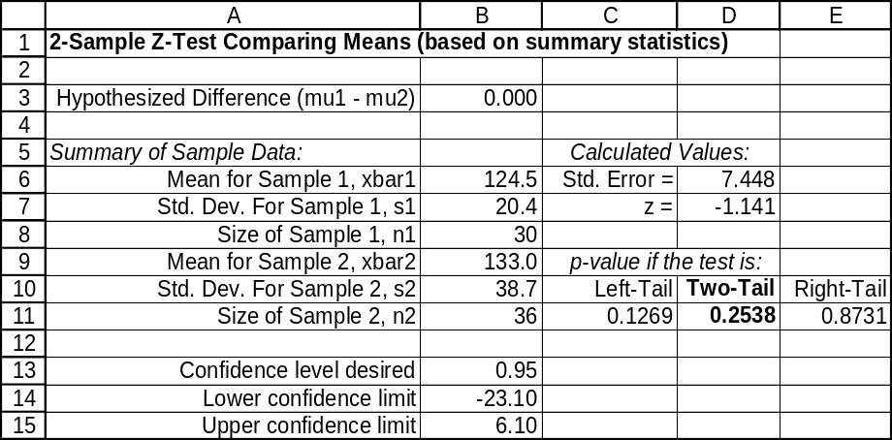

11.36 p/a/m The null and alternative hypotheses are:
H₀: μ₁ = μ₂ , or μ₁ - μ₂ = 0 (the average expenditures in the 2 regions are equal)
H₁: μ₁ ≠ μ₂ , or μ₁ - μ₂ ≠ 0 (the average expenditures in 2 regions are not equal)
₁ and ₂ are the sample average expenditures for entertainment in the Northeast and the West.
The test statistic is: 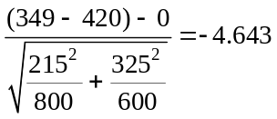
For a two-tail test at the 0.01 significance level, the critical values are z = -2.58 and z = 2.58.
The decision rule is "Reject H₀ if the calculated z < -2.58 or z > 2.58, otherwise do not reject."
Since the calculated test statistic falls in the rejection region, reject H₀. At the 0.01 level, the average expenditure for entertainment in the Northeast is significantly different from the average expenditure in the West.

Based on the summary statistics, Excel worksheet template tmz2test was used in generating the printout shown below. For this two-tail test, the p-value (0.0000) is less than the 0.01 level of significance being used to reach a conclusion, so H₀ is rejected. For a true H₀, the probability is virtually zero that such a large difference between the sample means could occur by chance. The 99% confidence interval for
(μ₁ - μ₂) is from -$110.4 to -$31.6. This interval does not include 0, so we conclude that (μ₁ - μ₂) could not be 0. The conclusion using the 99% confidence interval is consistent with the result of the two-tail hypothesis test at the 0.01 level of significance.
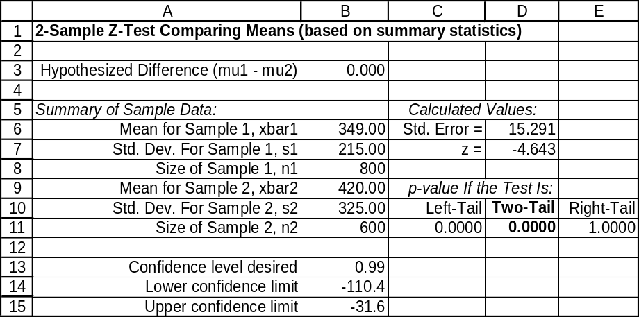

10.37 p/a/m The null and alternative hypotheses are:
H₀: μ₁ = μ₂ , or μ₁ - μ₂ = 0 (the average expenditures in the 2 towns are equal)
H₁: μ₁ ≠ μ₂ , or μ₁ - μ₂ ≠ 0 (the average expenditures in the 2 towns are not equal)
₁ and ₂ are the mean sample expenditures in the two towns.
The test statistic is: 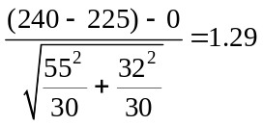
For a two-tail test at the 0.05 significance level, the critical values are z = -1.96 and z = 1.96.
The decision rule is "Reject H₀ if the calculated z < -1.96 or z > 1.96, otherwise do not reject." Since the calculated test statistic falls in the nonrejection region, do not reject H₀. At the 0.05 level, we can conclude the average veterinary-related expenditures for dog owners in the two towns could be the same.

Based on the summary statistics, Excel worksheet template tmz2test was used in generating the printout shown below. For this two-tail test, the p-value (0.1967) is not less than the 0.05 level of significance being used to reach a conclusion, so H₀ is not rejected.
The 95% confidence interval for (μ₁ - μ₂) is from -$7.77 to $37.77. This interval includes 0, so we conclude that (μ₁ - μ₂) could be 0. The conclusion using the 95% confidence interval is consistent with the result of the two-tail hypothesis test at the 0.05 level of significance.
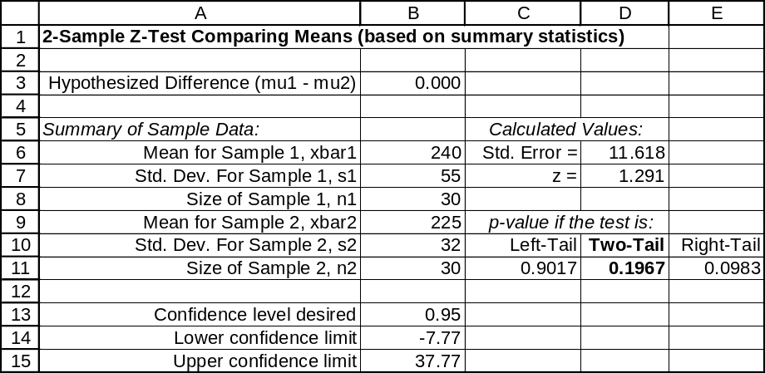

11.38 p/a/m The null and alternative hypotheses are:
H₀: μ₁ ≥ μ₂ , or μ₁ - μ₂ ≥ 0 (average stay for gum-chewers is no less than for non-chewers)
H₁: μ₁ < μ₂ , or μ₁ - μ₂ < 0 (average stay for gum-chewers is less than for non-chewers)
₁ and ₂ are the sample average number of days before discharge for gum-chewers and non-chewers.
The test statistic is: 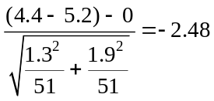
For a left-tail test at the 0.01 significance level, the critical value is z = -2.33. The decision rule is: "Reject H₀ if the calculated z < -2.33, otherwise do not reject." Since the calculated test statistic falls in the rejection region, reject H₀. At the 0.01 level, we can conclude the population mean number of days before discharge is lower for gum-chewers than for non-chewers.
Based on the summary statistics, Excel worksheet template tmz2test was used in generating the following printout. For this left-tail test, the p-value (0.0065) is less than the 0.01 level of significance being used to reach a conclusion, so H₀ is rejected. For a true H₀, the probability is only 0.0065 that the sample mean stay for the gum-chewers could be this much lower simply by chance.
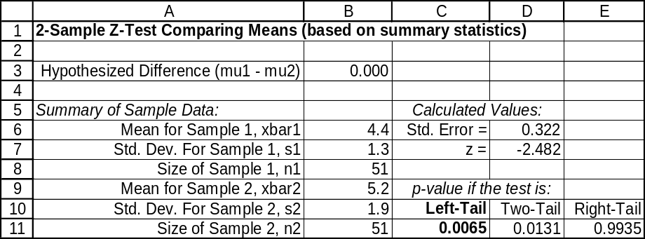

11.39 p/c/m The null and alternative hypotheses are:
H₀: μ₁ ≤ μ₂ , or μ₁ - μ₂ ≤ 0 (average days missed is no greater for overweight females)
H₁: μ₁ > μ₂ , or μ₁ - μ₂ > 0 (average days missed is greater for overweight females)
₁ and ₂ are the sample mean days missed for those who were overweight and of normal weight
The test statistic is: 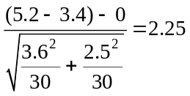
For a right-tail test at the 0.05 significance level, the critical value is z = 1.645. The decision rule is: "Reject H₀ if the calculated z > 1.645, otherwise do not reject." Since the calculated test statistic falls in the rejection region, reject H₀. At the 0.05 level, we can conclude the population mean number of days missed is greater for overweight women than for women of normal weight.
Based on the summary statistics, Excel worksheet template tmz2test was used in generating the following printout. For this right-tail test, the p-value (0.0122) is less than the 0.05 level of significance being used to reach a conclusion, so H₀ is rejected. For a true H₀, the probability is only 0.0122 that the sample mean days missed for the overweight females could have been this much greater simply by chance.
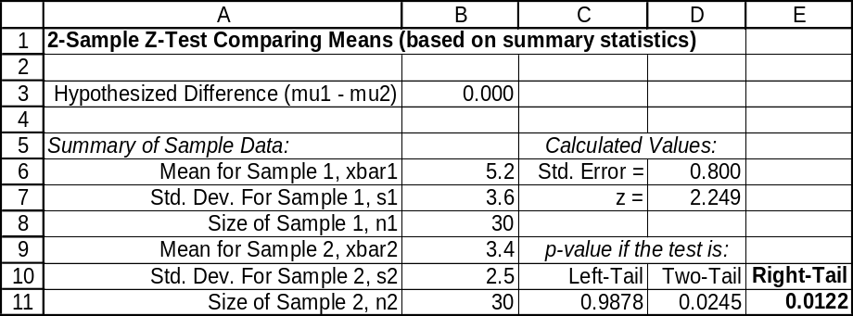

11.40 p/a/m The null and alternative hypotheses are:
H₀: μ₁ ≥ μ₂ , or μ₁ - μ₂ ≥ 0 (average IQ is at least as high for players frequently "heading" the ball)
H₁: μ₁ < μ₂ , or μ₁ - μ₂ < 0 (average IQ is lower for players frequently "heading" the ball)
₁ and ₂ are the average IQs for the samples of "headers" and "nonheaders".
The test statistic is: 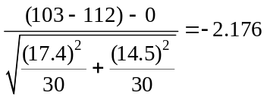

For this one-tail test at the 0.01 significance level, the critical value is z = -2.33. The decision rule is: "Reject H₀ if the calculated z < -2.33, otherwise do not reject." Since the calculated test statistic falls in the nonrejection region, do not reject H₀. At the 0.01 level, we are not able to conclude that players who frequently "head" the ball have lower IQs than players who do not frequently "head" the ball. If we had done the test at the 0.025 level, however, the critical z would have been z = -1.96 and the "header" group would have been significantly lower than the "nonheader" group.

Based on the summary statistics, Excel worksheet template tmz2test was used in generating the following printout. For this left-tail test, the p-value (0.0148) is not less than the 0.01 level of significance being used to reach a conclusion, so H₀ is not rejected. For a true H₀, the probability is 0.0148 that such a large negative difference between the sample means could occur by chance.
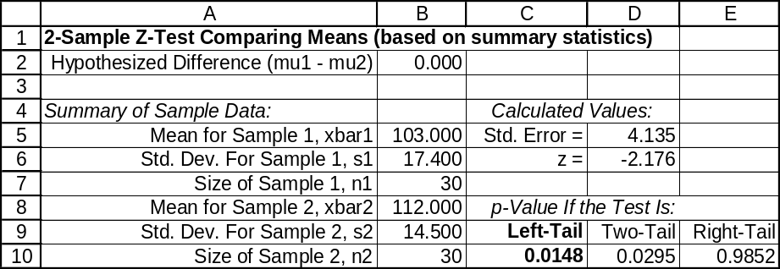

11.41 p/c/m The null and alternative hypotheses are:
H₀: μ₁ ≤ μ₂ , or μ₁ - μ₂ ≤ 0 (average waiting time in 2008 was no more than in 2003)
H₁: μ₁ > μ₂ , or μ₁ - μ₂ > 0 (average waiting time in 2008 was greater)
To apply the z-test, we must first use Excel or Minitab to obtain the summary statistics for the two samples, since Excel and Minitab do not provide the two-sample z-test for means. These summary statistics can then be used with Excel worksheet template tmz2test to produce the results shown below. For this right-tail test, the p-value (0.001) is less than the 0.05 level of significance being used to reach a conclusion, so H₀ is rejected and we conclude that the mean holding time in 2008 was greater than in 2003. For a true H₀, the probability is 0.001 that such a large positive difference between the sample means could occur by chance.
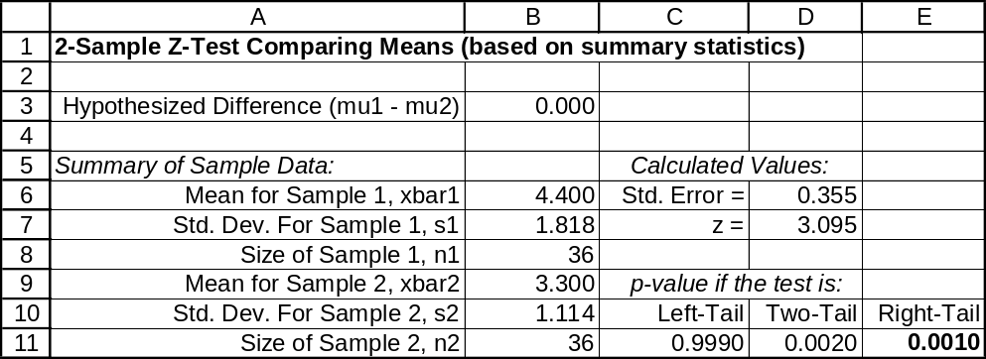

The unequal-variances t-test would provide comparable results, as shown in the Minitab printout:

Two-Sample T-Test and CI: 2008_mins, 2003_mins

Two-sample T for 2008_mins vs 2003_mins

N Mean StDev SE Mean
2008_mins 36 4.40 1.82 0.30
2003_mins 36 3.30 1.11 0.19

Difference = mu (2008_mins) - mu (2003_mins)
Estimate for difference: 1.100
95% lower bound for difference: 0.506
T-Test of difference = 0 (vs >): T-Value = 3.10 P-Value = 0.002 DF = 58

11.42 p/c/m The null and alternative hypotheses are:
H₀: μ₁ = μ₂ , or μ₁ - μ₂ = 0 (the two procedures are equally efficient)
H₁: μ₁ ≠ μ₂ , or μ₁ - μ₂ ≠ 0 (the two procedures are not equally efficient)
To apply the z-test, we must first use Excel or Minitab to obtain the summary statistics for the two samples, since Excel and Minitab do not provide the two-sample z-test for means. These summary statistics can then be used with Excel worksheet template tmz2test to produce the results shown below. For this two-tail test, the p-value (0.3880) is not less than the 0.10 level of significance being used to reach a conclusion, so H₀ is not rejected and we conclude that the two procedures could be equally efficient. For a true H₀, the probability is 0.3880 that a difference this great between the sample means could occur by chance. The 90% confidence interval for (μ₁ - μ₂) is from -0.788 to 2.528 units per hour. This interval includes 0, so we conclude that (μ₁ - μ₂) could be 0. The conclusion using the 90% confidence interval is consistent with the result of the two-tail hypothesis test at the 0.10 level of significance.
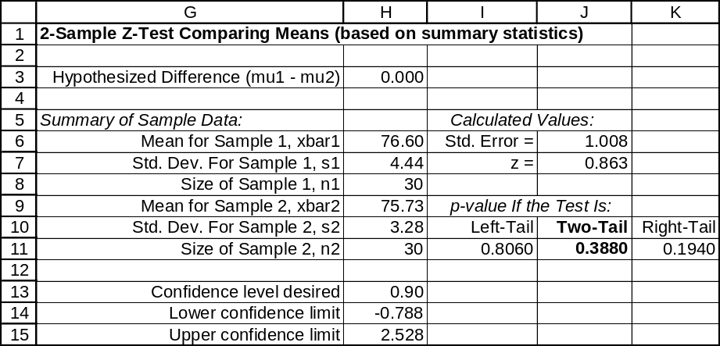

The unequal-variances t-test would provide comparable results, as shown in the Minitab printout:

Two-Sample T-Test and CI: proA, proB

Two-sample T for proA vs proB

N Mean StDev SE Mean
proA 30 76.60 4.44 0.81
proB 30 75.73 3.28 0.60

Difference = mu proA - mu proB
Estimate for difference: 0.87
90% CI for difference: (-0.82, 2.55)
T-Test of difference = 0 (vs not =): T-Value = 0.86 P-Value = 0.394 DF = 53

11.43 p/c/m The null and alternative hypotheses are:
H₀: μ₁ ≤ μ₂ , or μ₁ - μ₂ ≤ 0 (the experimental program is no better than the conventional program)
H₁: μ₁ > μ₂ , or μ₁ - μ₂ > 0 (the experimental program is better)
In order to apply the z-test, we must first use Excel or Minitab to obtain the summary statistics for the two samples. These summary statistics can then be used with Excel worksheet template tmz2test to produce the results shown below. For this right-tail test, the p-value (0.1178) is not less than the 0.025 level of significance being used to reach a conclusion, so H₀ is not rejected and we conclude that the experimental program may be no better than the conventional program. For a true H₀, the probability is 0.1178 that the sample mean for the experimental group could be this much larger than that for the conventional group simply by chance.
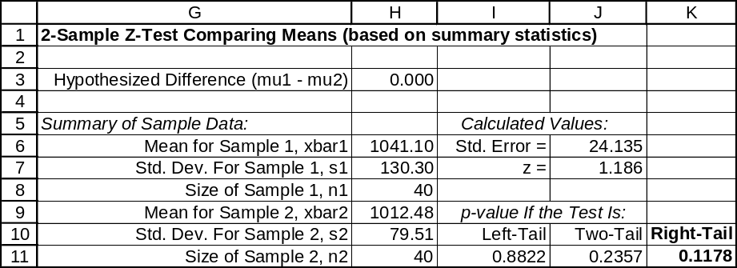

The unequal-variances t-test would provide comparable results, as shown in the Minitab printout:

Two-Sample T-Test and CI: NewProg, OldProg

Two-sample T for NewProg vs OldProg

N Mean StDev SE Mean
NewProg 40 1041 130 21
OldProg 40 1012.5 79.5 13

Difference = mu NewProg - mu OldProg
Estimate for difference: 28.6
95% lower bound for difference: -11.7
T-Test of difference = 0 (vs >): T-Value = 1.19 P-Value = 0.120 DF = 64

11.44 d/p/e This study involves dependent samples since the data consists of before and after measurements for the same individuals.

11.45 d/p/e This example involves dependent samples since all 20 consumers rate the taste of both brands of instant coffee.

11.46 d/p/e This is an example of independent samples since 10 tenured faculty are randomly selected from each college. They are not matched up in any way.

11.47 p/a/m
Truck number | x₁ = Current filter | x₂ = New filter | Difference, d = x₁ - x₂
1 | 7.6 | 7.3 | 0.3
2 | 5.1 | 7.2 | -2.1
3 | 10.4 | 6.8 | 3.6
4 | 6.9 | 10.6 | -3.7
5 | 5.6 | 8.8 | -3.2
6 | 7.9 | 8.7 | -0.8
7 | 5.4 | 5.7 | -0.3
8 | 5.7 | 8.7 | -3.0
9 | 5.5 | 8.9 | -3.4
10 | 5.3 | 7.1 | -1.8
The null and alternative hypotheses:
H₀: μ_{d} ≥ 0 (the new filter is not superior to the current filter)
H₁: μ_{d} < 0 (the new filter is superior to the current filter)
For each truck, d = x₁ - x₂ , with x₁ = mpg of trucks with current filter and x₂ = mpg of trucks with new filter. The sample mean and standard deviation for d are:
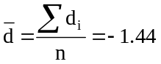 and 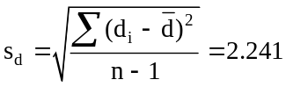
The test statistic is: 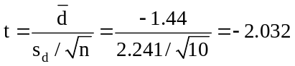
For a left-tail area of 0.05 and d.f. = (n - 1) = (10 - 1) = 9, the critical value is t = -1.833. The decision rule is: "Reject H₀ if the calculated t < -1.833, otherwise do not reject." Since the calculated test statistic falls in the rejection region, reject H₀. At the 0.05 level, it appears the new filtration system could be superior to the current one. The corresponding Minitab printout is shown below.

Paired T-Test and CI: Current, New

Paired T for Current – New

N Mean StDev SE Mean
Current 10 6.540 1.686 0.533
New 10 7.980 1.409 0.445
Difference 10 -1.440 2.241 0.709

95% upper bound for mean difference: -0.141
T-Test of mean difference = 0 (vs < 0): T-Value = -2.03 P-Value = 0.036

11.48 p/a/m For each person the difference is d = x₁ - x₂, with x₁ = pulse rate after seeing the billboard and x₂ = pulse rate before seeing the billboard. The null and alternative hypotheses are:
H₀: μ_{d} ≤ 0 (the average pulse rate does not increase)
H₁: μ_{d} > 0 (the average pulse rate does increase)
The test statistic is: 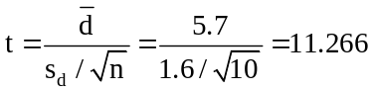
For a right-tail area of 0.01 and d.f. = (n - 1) = (10 - 1) = 9, the critical value is t = 2.821. The decision rule is "Reject H₀ if the calculated t > 2.821, otherwise do not reject." Since the calculated test statistic falls in the rejection region, reject H₀. At the 0.01 level, we can conclude the average pulse rate of those that view the billboard will increase. Therefore, the billboard stimulus appears to meet the agency's criterion for effectiveness.
As pointed out in the text, we can also use the one-sample t-test from chapter 10 in solving these kinds of problems. For example, based on the summary statistics given in this exercise, we can apply Excel worksheet template tmttest, which was introduced in chapter 10.
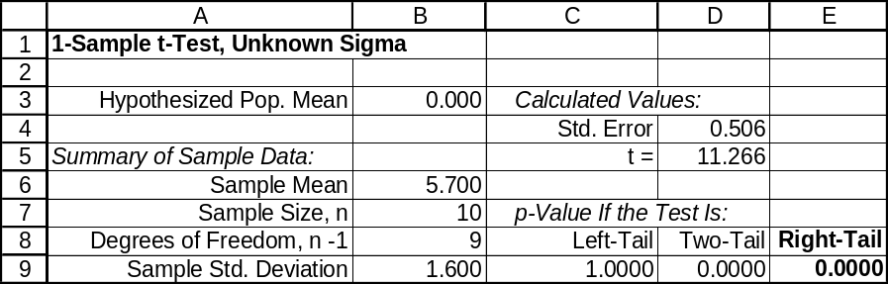

11.49 p/a/m
Person number | x₁ = Weight before | x₂ = Weight after | Difference, d = x₁ - x₂
1 | 198 | 194 | 4
2 | 154 | 151 | 3
3 | 124 | 126 | -2
4 | 110 | 104 | 6
5 | 127 | 123 | 4
6 | 162 | 155 | 7
7 | 141 | 129 | 12
8 | 180 | 165 | 15
The null and alternative hypotheses:
H₀: μ_{d} ≤ 0 (the aerobics class was not effective)
H₁: μ_{d} > 0 (the aerobics class was effective)
For each person the difference is d = x₁ - x₂ , with x₁ = weight before the class and x₂ = weight after the class. The sample mean and standard deviation for d are:
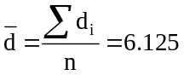 and 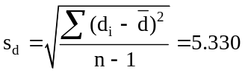
The test statistic is: 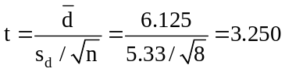
For a right-tail area of 0.05 and d.f. = (n - 1) = (8 - 1) = 7, the critical value is t = 1.895. The decision rule is: "Reject H₀ if the calculated t > 1.895, otherwise do not reject." Since the calculated test statistic falls in the rejection region, reject H₀. At the 0.05 level, we can conclude that the average weight of aerobic students is less after participating in the class. Therefore, the program is effective.
Using the t table with d.f. = 7, p-value = P(t ≥ 3.250) is between 0.005 and 0.01. The corresponding Minitab printout is shown below.

Paired T-Test and CI: Before, After

Paired T for Before – After

N Mean StDev SE Mean
Before 8 149.5 29.9 10.6
After 8 143.4 28.5 10.1
Difference 8 6.13 5.33 1.88

95% lower bound for mean difference: 2.55
T-Test of mean difference = 0 (vs > 0): T-Value = 3.25 P-Value = 0.007

11.50 p/c/m The null and alternative hypotheses:
H₀: μ_{d} ≥ 0 (average reaction time is not greater after drinking)
H₁: μ_{d} < 0 (average reaction time is greater after drinking)
The Minitab printout is shown below. For this left-tail test, the p-value (0.002) is less than the 0.005 level of significance being used to reach a conclusion, so H₀ is rejected. The program host has demonstrated his point. For a true H₀, the probability is only 0.002 of getting such a large negative mean change in reaction time just by chance.

Paired T-Test and CI: Before, After

Paired T for Before – After

N Mean StDev SE Mean
Before 5 0.3700 0.0339 0.0152
After 5 0.4620 0.0526 0.0235
Difference 5 -0.0920 0.0335 0.0150

95% upper bound for mean difference: -0.0601
T-Test of mean difference = 0 (vs < 0): T-Value = -6.15 P-Value = 0.002

11.51 p/c/m The null and alternative hypotheses:
H₀: μ_{d} = 0 (there is no difference in worker productivity on the two days)
H₁: μ_{d} ≠ 0 (there is a difference in worker productivity on the two days)
The Minitab printout is shown below. For this two-tail test, the p-value (0.170) is not less than the 0.01 level of significance being used to reach a conclusion, so H₀ is not rejected. There is no reason to believe that worker productivity differs for Monday versus Thursday. For a true H₀, the probability is 0.170 of getting a mean difference in productivity this far from zero just by chance. The 99% confidence interval for μ_{d} is from -4.663 to 1.774. Since zero is within the interval, we conclude that μ_{d} could be zero. This is the same conclusion reached in the hypothesis test.

Paired T-Test and CI: Monday, Thursday

Paired T for Monday – Thursday

N Mean StDev SE Mean
Monday 9 54.67 10.26 3.42
Thursday 9 56.11 10.90 3.63
Difference 9 -1.444 2.877 0.959

99% CI for mean difference: (-4.663, 1.774)
T-Test of mean difference = 0 (vs not = 0): T-Value = -1.51 P-Value = 0.170

11.52 c/a/m The null and alternative hypotheses are:
H₀: π₁ ≤ π₂ , or π₁ - π₂ ≤ 0 and H₁: π₁ > π₂ , or π₁ - π₂ > 0. The pooled estimate of the population proportions is: 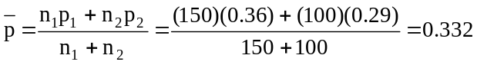
The test statistic is: 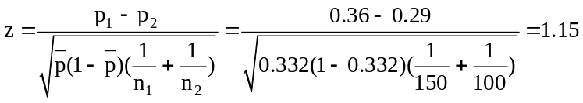
For a right-tail test at the 0.025 significance level, the critical value is z = 1.96. The decision rule is: "Reject H₀ if the calculated z > 1.96, otherwise do not reject." Since the calculated test statistic falls in the nonrejection region, do not reject H₀. At the 0.025 level, we conclude that the observed difference in the two sample proportions was due to chance. We are not able to conclude that π₁ is greater than π₂. Note that the numerator in our z statistic is p₁ - p₂, instead of (p₁ - p₂) - 0. This is consistent with the “case 1” scenario in which the hypothesized difference between the population proportions is always zero.

Based on the summary information in this exercise, Excel worksheet template tm2ptest was used in generating the following printout corresponding to this solution:
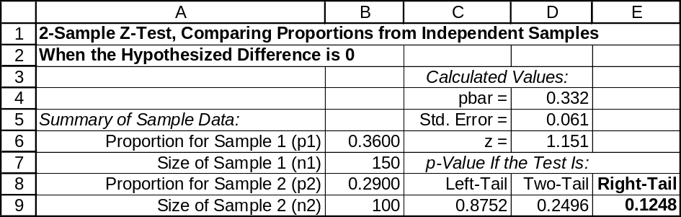

11.53 c/a/m The null and alternative hypotheses are:
H₀: π₁ = π₂ , or π₁ - π₂ = 0 (the population proportions are equal)
H₁: π₁ ≠ π₂ , or π₁ - π₂ ≠ 0 (the population proportions are not equal)
Based on the summary statistics, we will use Excel worksheet template tm2ptest to carry out this test. The test is two-tail, and the p-value (0.0286) is less than the 0.05 level of significance being used to reach a conclusion, so H₀ is rejected. For a true H₀, the probability is just 0.0286 that a difference this great between the sample proportions could occur by chance.
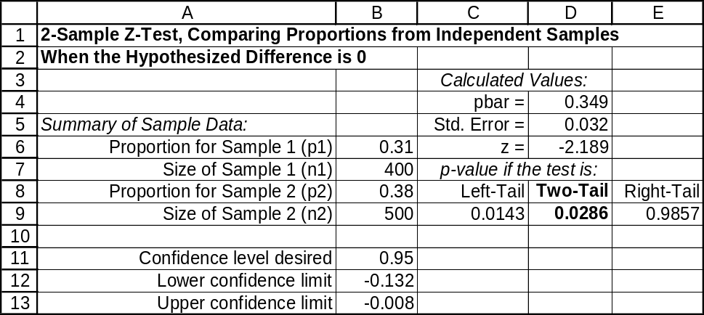

11.54 p/a/m The null and alternative hypotheses are:
H₀: π₁ ≤ π₂ , or π₁ - π₂ ≤ 0 (the new brochure is no better than the standard version)
H₁: π₁ > π₂ , or π₁ - π₂ > 0 (the new brochure is better than the standard version)
Based on the summary statistics, we will use Excel worksheet template tm2ptest to carry out this test. The test is right-tail, and the p-value (0.0751) is less than the 0.10 level of significance being used to reach a conclusion, so H₀ is rejected. For a true H₀, the probability is 0.0751 that p₁ would be this much larger than p₂ just by chance. At the 0.10 level, we conclude that the new brochure is better.
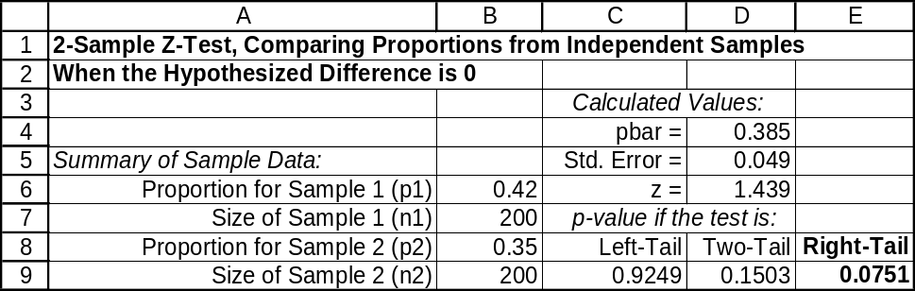

11.55 p/a/m The null and alternative hypotheses are:
H₀: π₁ ≤ π₂ , or π₁ - π₂ ≤ 0 (the success rate is no higher with a conventional PC than with mobile)
H₁: π₁ > π₂ , or π₁ - π₂ > 0 (the success rate is higher with a conventional PC)
The pooled estimate of the population proportions is:
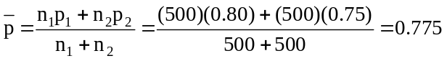
The test statistic is: 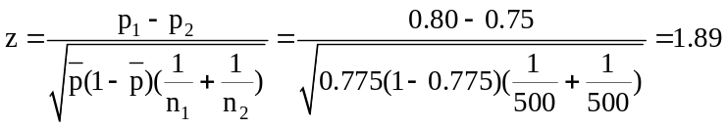
For a right-tail test at the 0.01 significance level, the critical value is z = 2.33. The decision rule is "Reject H₀ if the calculated z > 2.33, otherwise do not reject." Since the calculated test statistic falls in the nonrejection region, do not reject H₀. At the 0.01 level, we conclude that the observed difference in the two sample proportions was due to chance. From this test and using this level of significance, we are not able to conclude that the success rate with the conventional PC is higher than with touch-screen mobile devices.Note that the numerator in our z statistic is p₁ - p₂, instead of (p₁ - p₂) - 0. This is consistent with the “case 1” scenario in which the hypothesized difference between the population proportions is always zero.

Based on the summary information in this exercise, the Test Statistics workbook provided with Data Analysis Plus is used in generating the printout below. (Note the use of Case 1, applicable when the hypothesized value of the difference is zero.) The p-value in this right-tail test is 0.029, and it is not less than the 0.01 level of significance being used in reaching a conclusion. Thus, at this level of significance, we are not able to reject the null hypothesis.
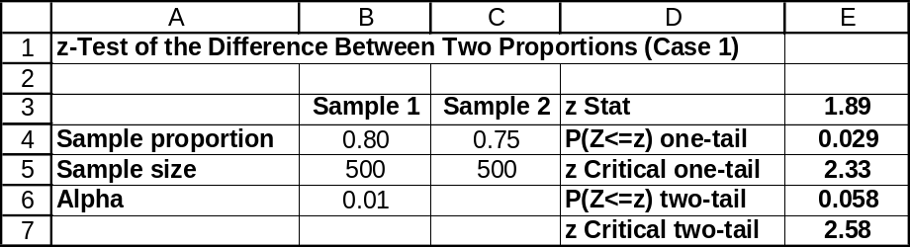

11.56 p/a/m The null and alternative hypotheses are:
H₀: π₁ = π₂ , or π₁ - π₂ = 0 (the proportions are equal for the two age groups)
H₁: π₁ ≠ π₂ , or π₁ - π₂ ≠ 0 (the proportions are not equal for the two age groups)
The pooled estimate of the population proportions is:
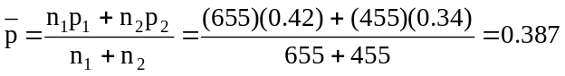
The test statistic is: 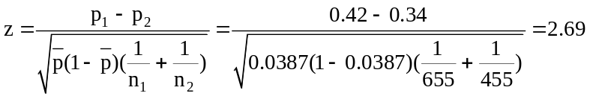
For a two-tail test at the 0.01 significance level, the critical values are z = -2.58 and z = 2.58.
The decision rule is: "Reject H₀ if the calculated z < -2.58 or > 2.58, otherwise do not reject."
Since the calculated test statistic falls in the rejection region, reject H₀. At the 0.01 level, we can reject the possibility that the population percentage of people in the two age groups that seldom or never eat cottage cheese could be equal.

Based on the summary information in this exercise, the Test Statistics workbook provided with Data Analysis Plus was used in generating the printout below. (Note the use of Case 1, applicable when the hypothesized value of the difference is zero.)
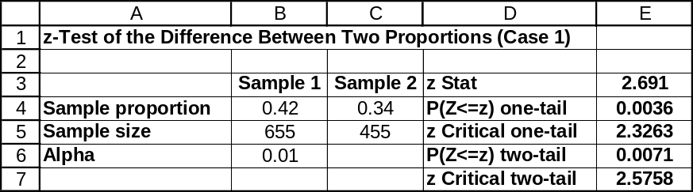

11.57 p/a/m The null and alternative hypotheses are:
H₀: π₁ = π₂ , or π₁ - π₂ = 0 (the proportions are equal for the two years)
H₁: π₁ ≠ π₂ , or π₁ - π₂ ≠ 0 (the proportions are not equal for the two years)
The pooled estimate of the population proportions is:
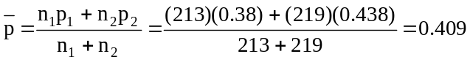
The test statistic is: 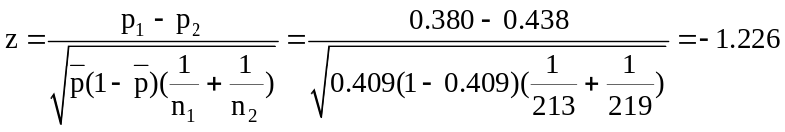
For a two-tail test at the 0.05 significance level, the critical values are z = -1.96 and z = 1.96.
The decision rule is: "Reject H₀ if the calculated z < -1.96 or > 1.96, otherwise do not reject." Since the calculated test statistic falls in the nonrejection region, do not reject H₀. At the 0.05 level, it appears the difference in the two proportions could have been the result of chance variation from one year to the next. Based on the summary information in this exercise, the Test Statistics workbook provided with Data Analysis Plus was used in generating the printout below. (Note the use of Case 1, applicable when the hypothesized value of the difference is zero.)
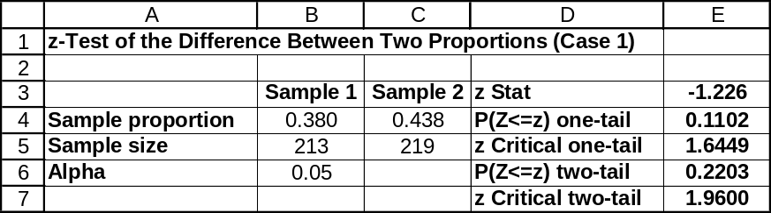

11.58 p/a/m The null and alternative hypotheses are:
H₀: π₁ = π₂ , or π₁ - π₂ = 0 (the two interviewers are equally capable)
H₁: π₁ ≠ π₂ , or π₁ - π₂ ≠ 0 (the two interviewers are not equally capable)
The sample proportions are p₁ = 45/200 = 0.225 and p₂ = 42/120 = 0.35. The pooled estimate of the population proportions is: 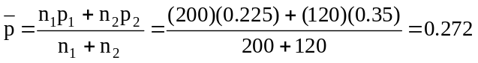
The test statistic is: 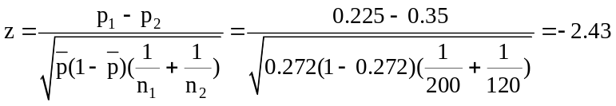
For a two-tail test at the 0.05 significance level, the critical values are z = -1.96 and z = 1.96.
The decision rule is: "Reject H₀ if the calculated z < -1.96 or > 1.96, otherwise do not reject."
Since the calculated test statistic falls in the rejection region, reject H₀. At the 0.05 level, we can reject the possibility that the interviewers are equally capable of obtaining interviews.
Based on the summary information in this exercise, the Test Statistics workbook provided with Data Analysis Plus is used in generating the printout below. (Note the use of Case 1, applicable when the hypothesized value of the difference is zero.)
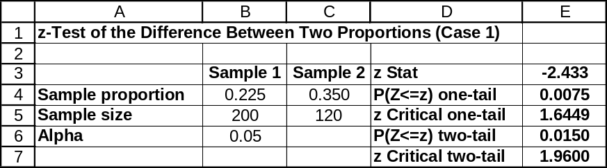

11.59 p/a/m The null and alternative hypotheses are:
H₀: π₁ = π₂ , or π₁ - π₂ = 0 (the proportions of multiple transactions are the same)
H₁: π₁ ≠ π₂ , or π₁ - π₂ ≠ 0 (the proportions of multiple transactions are not the same)
The pooled estimate of the population proportions is:
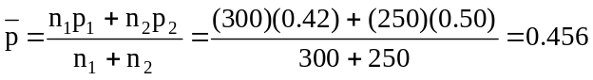
The test statistic is: 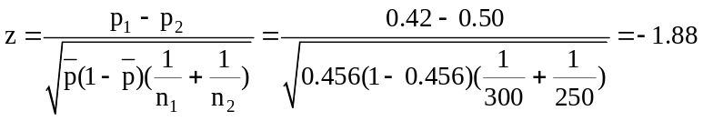
For a two-tail test at the 0.10 significance level, the critical values are z = -1.645 and z = 1.645.
The decision rule is: "Reject H₀ if the calculated z < -1.645 or > 1.645, otherwise do not reject."
Since the calculated test statistic falls in the rejection region, reject H₀. At the 0.10 level, we can conclude that males and females differ in terms of making multiple transactions. Using the standard normal table, the p-value = 2P(z ≤ -1.88) = 2(0.0301) = 0.0602.
Based on the summary information in this exercise, the Test Statistics and Estimators workbooks provided with Data Analysis Plus were used in generating the printouts below. In this two-tail test,
the p-value (0.0607) is less than 0.10, the level of significance used in reaching a conclusion, so we reject H₀ and conclude that the population proportions are not equal. For a true H₀, there would be only a 0.0607 probability of obtaining this great a difference between the sample proportions by chance.
The 90% confidence interval for (π₁ - π₂) is from -0.150 to -0.010. Since zero is not within the interval, we conclude that (π₁ - π₂) is some value other than zero. This is the same conclusion reached in the hypothesis test.
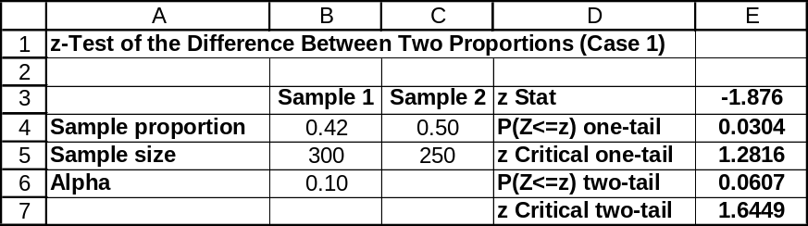

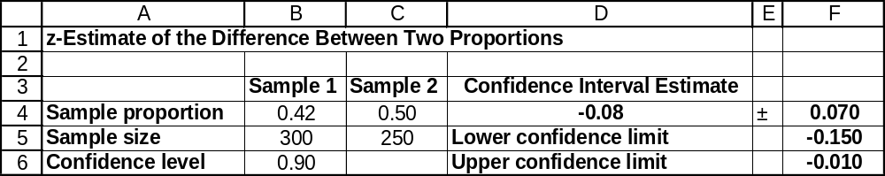

11.60 p/a/m The null and alternative hypotheses are:
H₀: π₁ = π₂ , or π₁ - π₂ = 0 (the two sales pitches are equivalent)
H₁: π₁ ≠ π₂ , or π₁ - π₂ ≠ 0 (the two sales pitches are not equivalent)
The pooled estimate of the population proportions is:
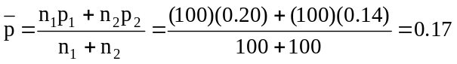
The test statistic is: 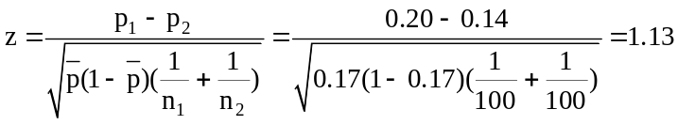
For a two-tail test at the 0.05 significance level, the critical values are z = -1.96 and z = 1.96.
The decision rule is: "Reject H₀ if the calculated z < -1.96 or > 1.96, otherwise do not reject."
Since the calculated test statistic falls in the nonrejection region, do not reject H₀. At the 0.05 level, we can conclude that the difference in the results was due to chance. There does not appear to be any difference in the two sales approaches. Using the standard normal table, p-value = 2P(z ≥ 1.13) = 2(1.0000 – 0.8708) = 2(0.1292) = 0.2584.

Based on the summary information in this exercise, the Test Statistics and Estimators workbooks provided with Data Analysis Plus were used in generating the printouts below. In this two-tail test,
the p-value (0.2587) is not less than 0.05, the level of significance used in reaching a conclusion, so we do not reject H₀. For a true H₀, there would be a 0.2587 probability of obtaining this great a difference between the sample proportions by chance. The 95% confidence interval for (π₁ - π₂) is from -0.0438 to 0.1638. Since zero is within the interval, we conclude that (π₁ - π₂) could be zero. This is the same conclusion reached in the hypothesis test.
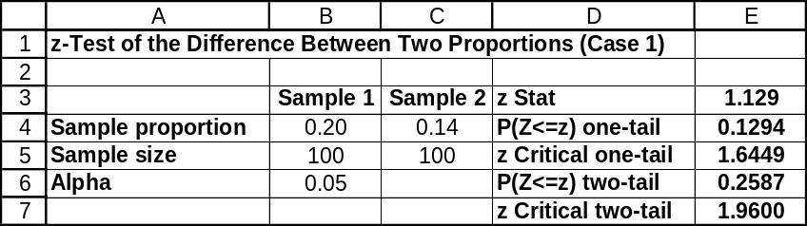

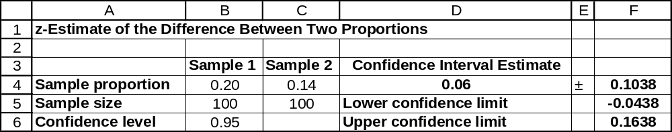

11.61 p/a/m The null and alternative hypotheses are:
H₀: π₁ ≤ π₂ , or π₁ - π₂ ≤ 0 (the illness rate is no higher for soldiers who were near the release)
H₁: π₁ > π₂ , or π₁ - π₂ > 0 (the illness rate is higher for soldiers who were near the release)
The pooled estimate of the population proportions is:
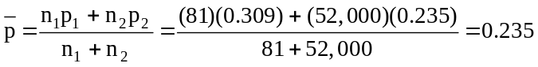
The test statistic is: 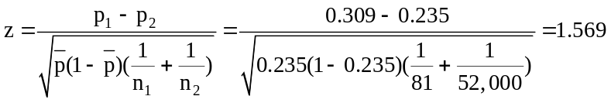
For a right-tail test at the 0.10 significance level, the critical value is z = 1.28. The decision rule is: "Reject H₀ if the calculated z > 1.28, otherwise do not reject." Since the calculated test statistic falls in the rejection region, reject H₀. At the 0.10 level, the soldiers in the vicinity of the nerve gas release do have a significantly higher rate of illness.

Based on the summary information in this exercise, the Test Statistics workbook provided with Data Analysis Plus was used in generating the printout below. In this right-tail test, the p-value (0.0583) is less than 0.10, the level of significance used in reaching a conclusion, so we reject H₀. For a true H₀, there is a 0.0583 probability that p₁ would be this much larger than p₂ by chance.
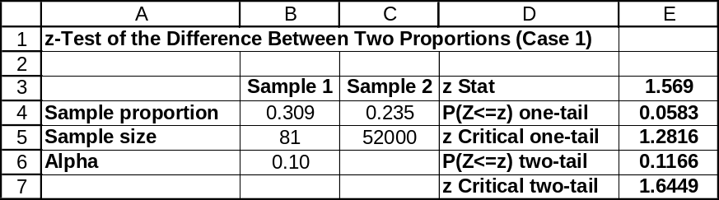

11.62 p/a/m The null and alternative hypotheses are:
H₀: π₁ ≤ π₂ , or π₁ - π₂ ≤ 0 (the 18-34 group are no more comfortable than the 55-64 group)
H₁: π₁ > π₂ , or π₁ - π₂ > 0 (the 18-34 group are more comfortable with electronic filing)
This exercise could be solved using formulas and pocket calculator, but we will use the Test Statistics workbook provided with Data Analysis Plus. In this right-tail test, the p-value (0.0024) is less than 0.025, the level of significance used in reaching a conclusion, so we reject H₀. For a true H₀, there is only a 0.0024 probability that p₁ would be this much larger than p₂ by chance.
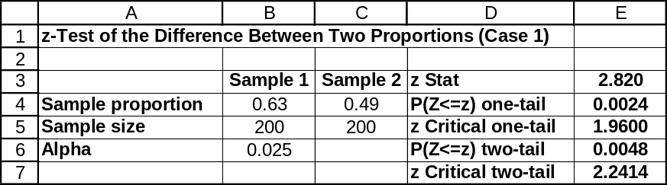

11.63 p/c/m The null and alternative hypotheses are:
H₀: π₁ = π₂ , or π₁ - π₂ = 0 (females and males feel feel equally stressed about their work/life balance)
H₁: π₁ ≠ π₂ , or π₁ - π₂ ≠ 0 (females and males do not feel equally stressed about work/life balance)
Using Data Analysis Plus, we obtain the printouts below. In this two-tail test, the p-value (0.057) is not less than 0.01, the level of significance used in reaching a conclusion, so we do not reject H₀.
The population proportions could be equal. For a true H₀, there would be a 0.057 probability of obtaining this great a difference between the sample proportions by chance. The 99% confidence interval for
(π₁ - π₂) is from -0.031 to 0.211. Since zero is within the interval, we conclude that (π₁ - π₂) could be zero. This is the same conclusion reached in the hypothesis test.
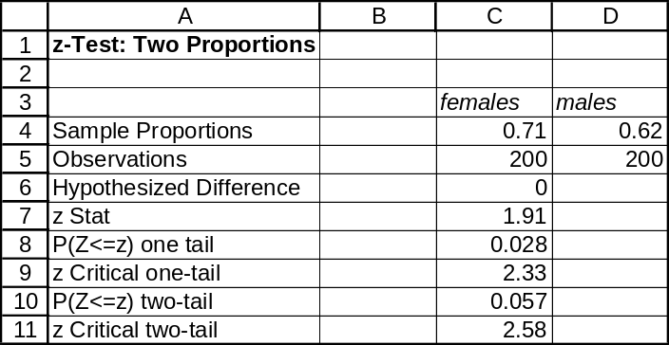

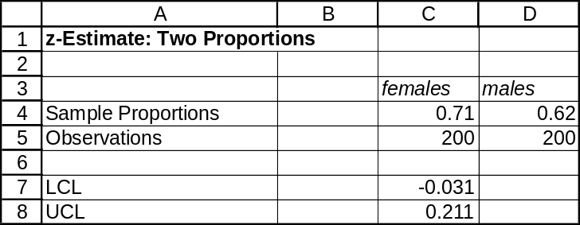

11.64 p/c/m The null and alternative hypotheses are:
H₀: π₁ ≥ π₂ , or π₁ - π₂ ≥ 0 (the training is not effective)
H₁: π₁ < π₂ , or π₁ - π₂ < 0 (the training is effective)
Using Data Analysis Plus, we obtain the printout below. In this left-tail test, the p-value (0.016) is less than 0.05, the level of significance used in reaching a conclusion, so we reject H₀. We conclude that the training is effective. For a true H₀, there would be only a 0.016 probability that p₁ would be this much smaller than p₂ simply by chance.
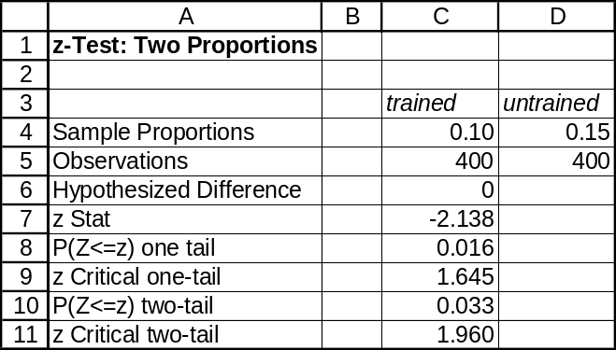

11.65 p/c/m The null and alternative hypotheses are:
H₀: π₁ = π₂ , or π₁ - π₂ = 0 (the population proportions for females 25-34 are the same)
H₁: π₁ ≠ π₂ , or π₁ - π₂ ≠ 0 (the proportions are not the same)
Using Data Analysis Plus, we obtain the printouts below. In this two-tail test, the p-value (0.1866) is not less than 0.10, the level of significance used in reaching a conclusion, so we do not reject H₀.
The population proportions could be equal. For a true H₀, there is a 0.1866 probability of obtaining this great a difference between the sample proportions by chance. The 90% confidence interval for (π₁ - π₂) is from -0.055 to 0.005. Since zero is within the interval, we conclude that (π₁ - π₂) could be zero. This is the same conclusion reached in the hypothesis test.
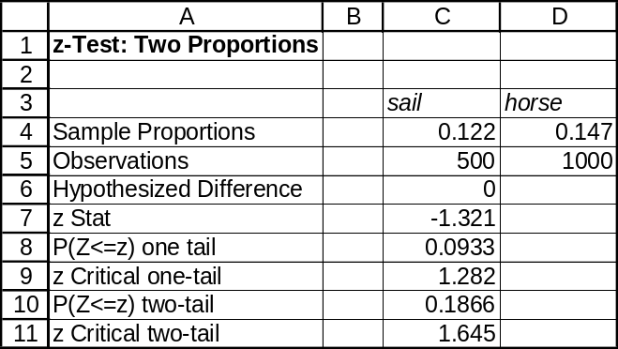

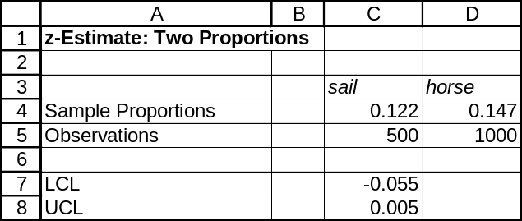

11.66 c/a/d The null and alternative hypotheses are:
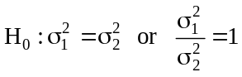 and 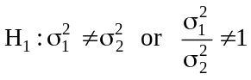
Since s₁ > s₂, the test statistic is: 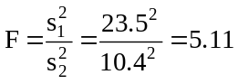
For this test, α = 0.10, v₁ = (n₁ - 1) = 9, and v₂ =(n₂ - 1) = 8. Referring to the F table with an
upper-tail area of 0.10/2 = 0.05, with v₁ = 9 and v₂ = 8, the critical value is F = 3.39. The decision rule is: "Reject H₀ if the calculated F > 3.39, otherwise do not reject." Since the calculated test statistic falls in the rejection region, reject H₀. At the 0.10 level, we conclude that the population variances are different.
If the test had been conducted at the 0.05 level, we would refer to the F table with an upper-tail area of 0.05/2 = 0.025. The critical value would then be F = 4.36. Since the calculated test statistic falls in the rejection region, reject H₀. Therefore, the conclusion will be the same at the 0.05 level as it is at the 0.10 level.
If the test had been conducted at the 0.02 level, we would refer to the F table with an upper-tail area of 0.02/2 = 0.01. The critical value would then be F = 5.91. Since the calculated test statistic falls in the nonrejection region, do not reject H₀. Therefore, the conclusion will not be the same at the 0.02 level as it is at the 0.10 level.

Using the Test Statistics workbook that accompanies Data Analysis Plus, we obtain the printout below. For this two-tail test, the p-value is shown as 0.031.
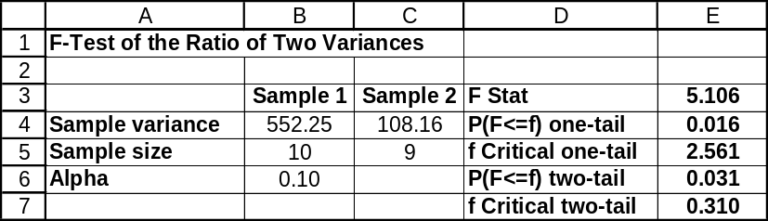

11.67 c/a/d The null and alternative hypotheses are:
and
Since s₁ < s₂, the test statistic is: 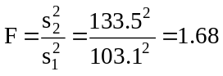
For this test, α = 0.10, v₁ = (n₂ - 1) = 40, and v₂ = (n₁ - 1) = 27. Referring to the F table with an upper-tail area of 0.10/2 = 0.05, with v₁ = 40 and v₂ = 27, the critical value is F = 1.84. The decision rule is "Reject H₀ if the calculated F > 1.84, otherwise do not reject." Since the calculated test statistic falls in the nonrejection region, do not reject H₀. At the 0.10 level, we cannot conclude that the population variances are different. Since we cannot reject H₀ at the 0.10 level of significance, we also will not be able to reject H₀ at the 0.05 and 0.02 levels. The critical value will increase as the level of significance decreases. (Note: when α = 0.05 the critical value is F = 2.07 and when α = 0.02 the critical value is F = 2.38.)
Using the Test Statistics workbook that accompanies Data Analysis Plus, we obtain the printout below. Although it isn’t really necessary when using this workbook’s F-test based on summary data,
we have been consistent with the procedure described in the text by designating the sample with the larger variance as sample 1. For this two-tail test, the p-value is shown as 0.161.
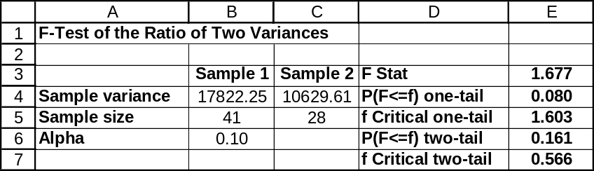

11.68 p/a/d In this exercise, we'll use the pocket-calculator approach, then supplement it with the results from Excel. First, the less convenient of the two approaches:
For the data in exercise 11.10, s₁² = 1.594, n₁ = 8, s₂² = 0.679, and n₂ = 8. The null and alternative hypotheses are:
and
Since s₁ > s₂, the test statistic is: 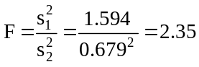
For this test, α = 0.02, v₁ = (n₁ - 1) = 7, and v₂ = (n₂ - 1) = 7. Referring to the F table with an upper-tail area of 0.02/2 = 0.01, with v₁ = 7 and v₂ = 7, the critical value is F = 6.99. The decision rule is: "Reject H₀ if the calculated F > 6.99, otherwise do not reject." Since the calculated test statistic falls in the nonrejection region, do not reject H₀. At the 0.02 level, we are justified in assuming that the population variances are equal.
If the standard deviation of the new battery type had been 20% larger (i.e., s₁ = 1.515), the test statistic would then be: 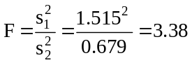
In this case, the calculated test statistic falls in the nonrejection region, so we do not reject H₀. Therefore, our conclusion would not change if the standard deviation of the new battery type had been 20% larger. The Excel counterpart is shown below. Data for the new battery had the greater variance, so this sample was designated as sample number 1. Because this was a two-tail test at the α = 0.02 level of significance, we specified 0.01 in the Excel dialog box -- again, this is because Excel always assumes we are doing a one-tail test. For this two-tail test, the p-value is double the one-tail area shown by Excel, or 2(0.1414) = 0.2828. The results are comparable to those obtained using the formulas in the procedure described above.
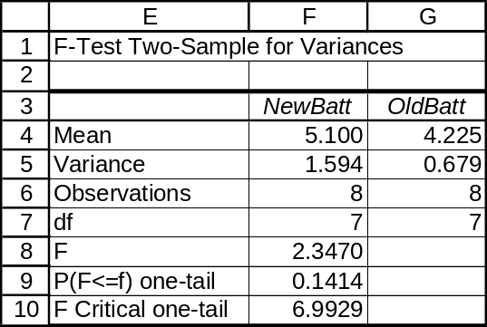

11.69 p/a/d For the data in exercise 11.11, s₁² = 4.41, n₁ = 11, s₂² = 3.24, and n₂ = 11. A pocket calculator and formulas could be used for this exercise, but we will use the computer. The null and alternative hypotheses are:
and
Since s₁ > s₂, the test statistic is 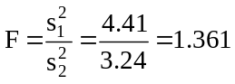, as in the first of the printouts below. The printouts were generated using the Test Statistics workbook that accompanies Data Analysis Plus. For the two-tail test of whether the variances in exercise 11.11 could be equal, the p-value is 0.6351, as shown in cell E6 in the first printout below. This is not less than the 0.05 level of significance being used to reach a conclusion, so H₀ is not rejected. We were justified in assuming the population variances were equal.

If the standard deviation for the FoodFarm jars had been 3.0 grams, the test result would have been as shown in the second of the printouts below and the two-tail p-value would have been 0.1226. Again, the p-value would not be less than the 0.05 level of significance and we would not reject H₀. The conclusion has not changed.
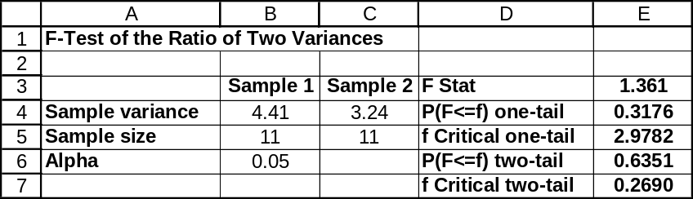

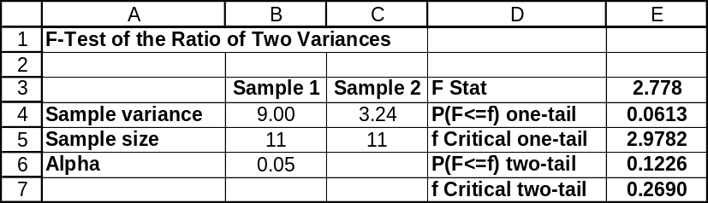

11.70 p/a/d A pocket calculator and formulas could be used for this exercise, but we will use the computer. The null and alternative hypotheses are:
and
Note: Because s₂ > s₁, if we were using a pocket calculator and the procedure described in the text, the test statistic would be calculated as 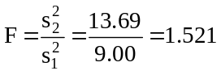. However, when we use the F-test in the Test Statistics workbook that accompanies Data Analysis Plus, there is no such need to designate the sample with the greater variance as sample 1. As a result, we will maintain the “sample 1” and “sample 2” designations as they are described in the exercise and the test statistic will be the inverse of the one shown above, or 1/1.521 = 0.657. This value is automatically calculated and displayed in the printout.

For the two-tail test of whether the variances (and, hence, the standard deviations) could be equal,
the p-value is 0.143. This is not less than the 0.02 level of significance being used to reach a conclusion, so H₀ is not rejected. We conclude that the population standard deviations of the lifetimes for these two types of appliances could be the same.
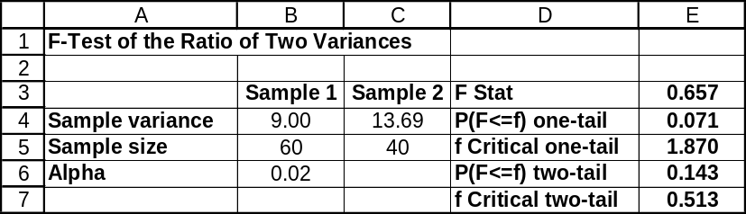

11.71 p/a/d A pocket calculator and formulas could be used for this exercise, but we will use the computer. The null and alternative hypotheses are:
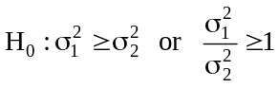 and 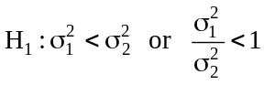
Note: Because s₂ > s₁, if we were using a pocket calculator and the procedure described in the text, the test statistic would be calculated as 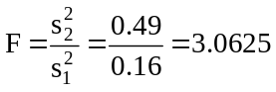. However, when we use the F-test in the Test Statistics workbook that accompanies Data Analysis Plus, there is no such need to designate the sample with the greater variance as sample 1. As a result, we will maintain the “sample 1” and “sample 2” designations as they are described in the exercise and the test statistic will be the inverse of the one shown above, or 1/3.0625 = 0.3265. This value is automatically calculated and displayed in the printout.

For this one-tail test, the p-value is 0.004. This is less than the 0.025 level of significance being used to reach a conclusion, so H₀ is rejected. We conclude that vendor 2 (sample 2 in the printout) has a higher population variance (and, hence, standard deviation) of shipping times than its more-consistent competitor.
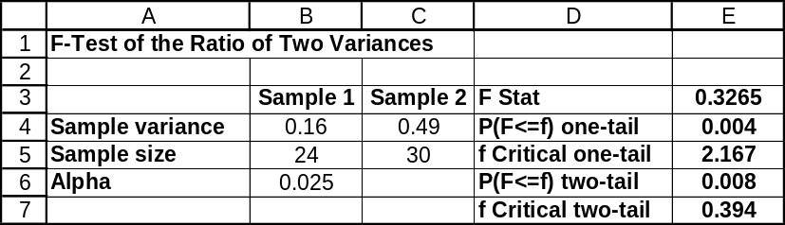

11.72 p/c/d The null and alternative hypotheses are:
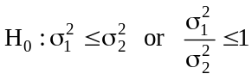 and 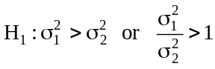
In using Excel in this one-tail test, we will specify the sample with the larger variance as sample number 1 (left column). In these data, the sample variance was higher for the females. In this data file for this exercise, the column with data for the females is already on the left, so just specify this data field as sample 1. Be sure to specify the 0.025 level of significance in carrying out the test. (Note: Excel always assumes we are doing a one-tail test, so this is no problem for our one-tail test. Just use the sample with the larger variance as sample 1 and enter the α = 0.025 level of significance.)

The Excel printout and a portion of its Minitab counterpart are shown below. Also note that Minitab assumes a two-tail test, so its two-tail p-value must be divided in half to get the p-value for this one-tail test. The p-value for this one-tail test is 0.0939, which is not less than the α = 0.025 level of significance that was specified. At the 0.025 level, we do not reject H₀. At the 0.025 level, we conclude that females do not have a higher variability in shopping time compared to males.
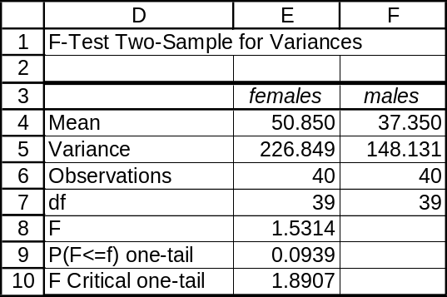

Test for Equal Variances

F-Test (normal distribution)

Test Statistic: 1.531
P-Value : 0.188

11.73 p/c/d The null and alternative hypotheses are:
and
In using Excel in this two-tail test at the 0.05 level, we will specify the sample with the larger variance as sample number 1 (left column). In these data, the sample variance was higher for the subscribers to internet provider B. Although we are performing a two-tail test at the 0.05 level, specify 0.025 as the level of significance -- this is because Excel always assumes we are doing a one-tail test.

The Excel printout and a portion of its Minitab counterpart are shown below. The p-value for this two-tail test is 2(0.009) = 0.018, which is less than the α = 0.05 level of significance on which we are basing our conclusion. At the 0.05 level, we reject H₀ and conclude that these two internet providers do not have the same variance in the ages of their respective customers.
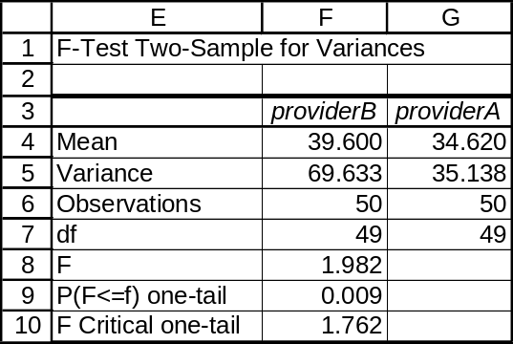

Test for Equal Variances

F-Test (normal distribution)

Test Statistic: 1.982
P-Value : 0.018

11.74 p/c/d The null and alternative hypotheses are:
and
In using Excel in this two-tail test at the 0.05 level, we will specify the sample with the larger variance as sample number 1 (left column). In these data, the sample variance was higher for the rates of return associated with mutual fund B. Although we are performing a two-tail test at the 0.05 level, specify 0.025 as the level of significance -- this is because Excel always assumes we are doing a one-tail test.

The Excel printout and a portion of its Minitab counterpart are shown below. The p-value for this two-tail test is 2(0.0517) = 0.1034, which is not less than the α = 0.05 level of significance on which we are basing our conclusion. At the 0.05 level, we do not reject H₀. Our conclusion is that these two mutual funds could be the same in terms of their performance variability.
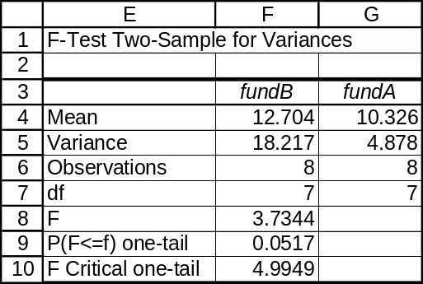

Test for Equal Variances

F-Test (normal distribution)

Test Statistic: 3.734
P-Value : 0.103

CHAPTER EXERCISES
11.75 p/a/m The null and alternative hypotheses are:
H₀: μ₁ ≤ μ₂ , or μ₁ - μ₂ ≤ 0 (Emily's suspicion is not warranted)
H₁: μ₁ > μ₂ , or μ₁ - μ₂ > 0 (Emily's suspicion is warranted)
₁ and ₂ are the average repair estimates given to women and men.
The pooled estimate of the common variance, and the test statistic, t, are:
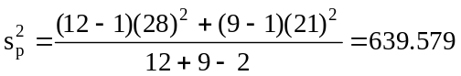 and 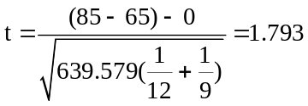
For a right-tail area of 0.05 and d.f. = (n₁ + n₂ - 2) = (12 + 9 - 2) = 19, the critical value is t = 1.729. The decision rule is: "Reject H₀ if the calculated t > 1.729, otherwise do not reject." Since the calculated test statistic falls in the rejection region, reject H₀. At the 0.05 level, Emily's suspicion appears to be warranted. We can conclude that TV repair shops tend to charge women more than they do men.
Using the t table with d.f. = 19, p-value = P(t ≥ 1.793) is between 0.025 and 0.05. Based on the summary information in this exercise, we have used Excel worksheet template tmt2pool in generating the following printout corresponding to this solution.
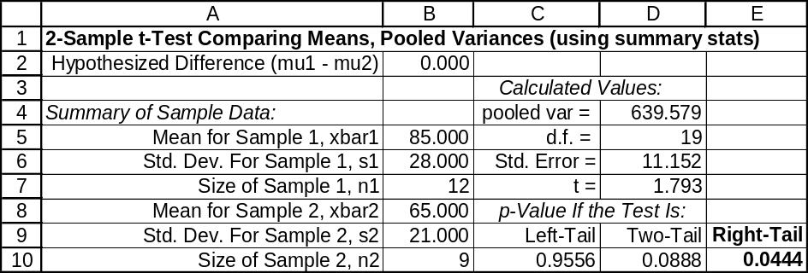

11.76 p/a/m The null and alternative hypotheses are:
H₀: μ₁ ≥ μ₂ , or μ₁ - μ₂ ≥ 0 (towing the trailer does not use less fuel than using the carrier)
H₁: μ₁ < μ₂ , or μ₁ - μ₂ < 0 (towing the trailer does use less fuel than using the carrier)
₁ and ₂ are the average miles per gallon results with the trailer and the roof-top carrier.
The pooled estimate of the common variance, and the test statistic, t, are:
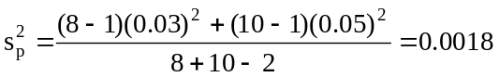 and 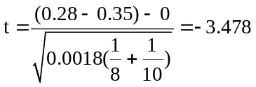
For a left-tail area of 0.01 and d.f. = (n₁ + n₂ - 2) = (8 + 10 - 2) = 16, the critical value is t = -2.583.
The decision rule is: "Reject H₀ if the calculated t < -2.583, otherwise do not reject." Since the calculated test statistic falls in the rejection region, reject H₀. At the 0.01 level, we can conclude that pulling the trailer uses significantly less fuel than driving with the roof-top carrier. Based on the summary information in this exercise, we have used Excel worksheet template tmt2pool in generating the following printout corresponding to this solution.
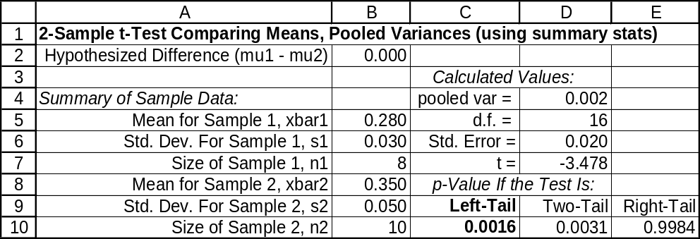

11.77 p/a/m The null and alternative hypotheses are:
H₀: μ₁ = μ₂ , or μ₁ - μ₂ = 0 (the two designs are equal at handling air pressure)
H₁: μ₁ ≠ μ₂ , or μ₁ - μ₂ ≠ 0 (the two designs are not equal at handling air pressure)
₁ and ₂ are the average air pressures handled by designs A and B.
The pooled estimate of the common variance, and the test statistic, t, are:
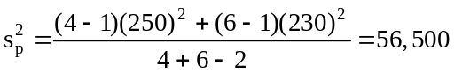 and 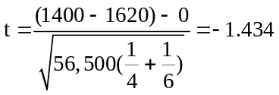
For a right-tail area of 0.10/2 = 0.05 and d.f. = (n₁ + n₂ - 2) = (4 + 6 - 2) = 8, the critical values are
t = -1.860 and t = 1.860. The decision rule is: "Reject H₀ if the calculated t < -1.860 or > 1.860, otherwise do not reject." Since the calculated test statistic falls in the nonrejection region, do not reject H₀. At the 0.10 level, we cannot conclude that the two designs differ in the average amount of air pressure they can withstand. The observed difference between the two designs' means is judged to have been due to chance. Using the t table with d.f. = 8, P(t ≤ -1.434) is between 0.05 and 0.10. Therefore, p-value = 2P(t ≤ -1.434) is between 0.10 and 0.20.
Given the summary data, we can also carry out this pooled-variances t-test using the Test Statistics and Estimators workbooks that accompany Data Analysis Plus. Recall that it is first necessary to square the sample standard deviations (250 and 230) to obtain the sample variances (62,500 and 52,900). For this two-tail test, the p-value (0.190) is not less than the 0.10 level of significance being used to reach a conclusion, so H₀ is not rejected. For a true H₀, there is a 0.190 probability that this much of a difference between the sample means could occur by chance. The 90% confidence interval for (μ₁ - μ₂) is from -505.32 to 65.32, This interval includes 0, so the actual difference between the population means could be 0. The conclusion using the 90% confidence interval is consistent with the results of the two-tail hypothesis test at the 0.10 level of significance.
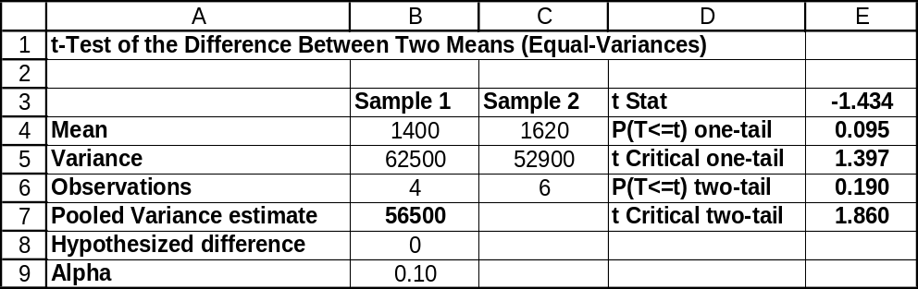

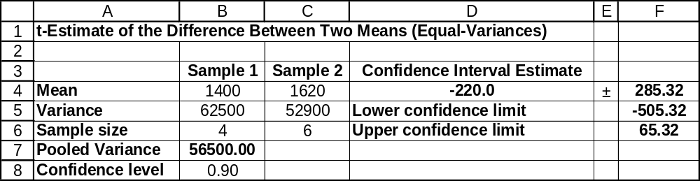

11.78 p/a/m The null and alternative hypotheses are:
H₀: μ₁ ≤ μ₂ , or μ₁ - μ₂ ≤ 0 (the engineer's claim is not correct)
H₁: μ₁ > μ₂ , or μ₁ - μ₂ > 0 (the engineer's claim is correct)
Assume σ₁ = σ₂, and ₁ and ₂ are the average number of units produced per hour using the new and standard layouts. The pooled estimate of the common variance, and the test statistic, t, are:
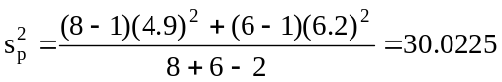 and 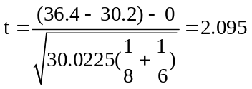
For a right-tail area of 0.025 and d.f. = (n₁ + n₂ - 2) = (8 + 6 - 2) = 12, the critical value is t = 2.179.
The decision rule is: "Reject Ho if the calculated t > 2.179, otherwise do not reject." Since the calculated test statistic falls in the nonrejection region, do not reject H₀. At the 0.025 level, we cannot conclude that the industrial engineer's claim is correct. The new workstation layout does not appear to increase production efficiency. The observed difference between the two layouts' means is judged to have been due to chance.

Given the summary data, we can also carry out this pooled-variances t-test using the Test Statistics workbook that accompanies Data Analysis Plus. Recall that it is first necessary to square the sample standard deviations (4.9 and 6.2) to obtain the sample variances (24.01 and 38.44). For this right-tail test, the p-value (0.029) is not less than the 0.025 level of significance being used to reach a conclusion, so H₀ is not rejected. For a true H₀, there is a 0.029 probability that the mean for sample 1 could be this much larger than that for sample 2 due to chance.
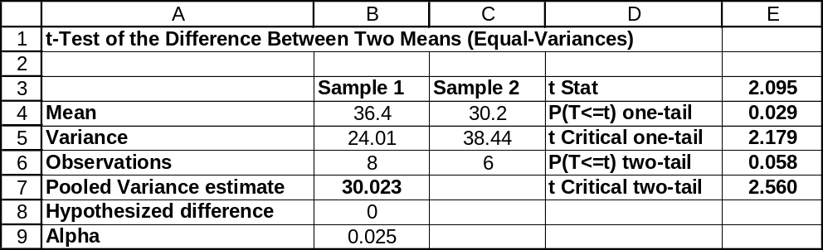

11.79 p/a/m The null and alternative hypotheses are:
H₀: μ₁ ≤ μ₂ , or μ₁ - μ₂ ≤ 0 (the modifications are not effective in reducing the down-hill times)
H₁: μ₁ > μ₂ , or μ₁ - μ₂ > 0 (the modifications are effective in reducing the down-hill times)
₁ and ₂ are the average times for the standard and new designs.
The pooled estimate of the common variance, and the test statistic, t, are:
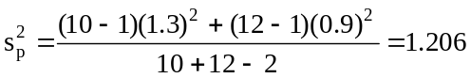 and 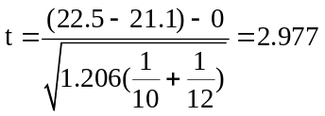
For a right-tail area of 0.01 and d.f. = (n₁ + n₂ - 2) = (10 + 12 - 2) = 20, the critical value is t = 2.528.
The decision rule is: "Reject H₀ if the calculated t > 2.528, otherwise do not reject." Since the calculated test statistic falls in the rejection region, reject H₀. At the 0.01 level, we conclude that the modifications are effective in reducing the down-hill times of the Soap Box Derby racer. Thus, the observed reduction in average times is judged to have not occurred by chance. Using the t table with d.f. = 20, the p-value is
P(t ≥ 2.977), which is less than 0.005. With this kind of engineering, Bob looks like a sure winner.

Given the summary data, we can also carry out this pooled-variances t-test using the Test Statistics workbook that accompanies Data Analysis Plus. Recall that it is first necessary to square the sample standard deviations (1.3 and 0.9) to obtain the sample variances (1.69 and 0.81). For this right-tail test, the p-value (0.004) is less than the 0.01 level of significance being used to reach a conclusion, so H₀ is rejected. For a true H₀, there is only a 0.004 probability that the mean for sample 2 could be this much less than that for sample 1 simply due to chance.
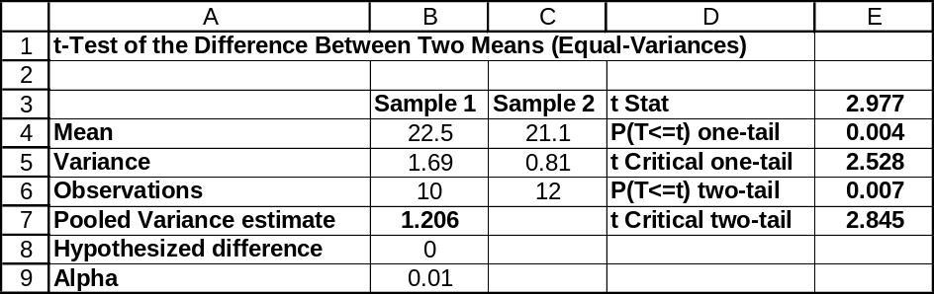

11.80 p/a/m The null and alternative hypotheses are:
H₀: μ₁ ≤ μ₂ , or μ₁ - μ₂ ≤ 0 (the new rod is not superior to the conventional one)
H₁: μ₁ > μ₂ , or μ₁ - μ₂ > 0 (the new rod is superior to the conventional one)
₁ and ₂ are the average tensile strengths for the new and conventional rods.
Assuming σ₁ ≠ σ₂, we will use the unequal-variances t-test and the computer. Hand calculations for the
t statistic and d.f. can be carried out as shown below.
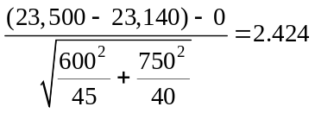
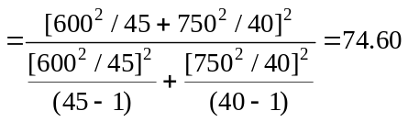
In the d.f. = 75 row of the t distribution table, the critical value for a right-tail test at the 0.01 level of significance is t = 2.377. The calculated t (2.424) exceeds 2.377, so we reject H₀ and conclude that the new welding rod is better. Based on the t table alone, the p-value is between 0.01 and 0.005.

Given the summary data, we can also carry out this unequal-variances t-test using the Test Statistics workbook that accompanies Data Analysis Plus. Recall that it is first necessary to square the sample standard deviations (600 and 750) to obtain the sample variances (360,000 and 562,500). The exact
p-value is listed as 0.009. Since this is less than the 0.01 level of significance being used to reach a conclusion, we reject H₀. For a true H₀, there is only a 0.009 probability that the mean for the new-rod sample would be this much better than that for the conventional-rod sample simply due to chance.
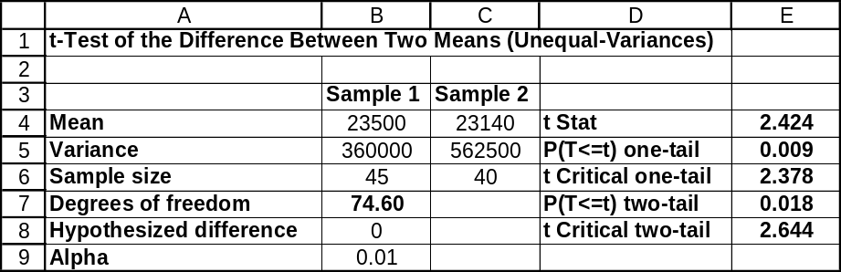

11.81 p/a/m The null and alternative hypotheses are:
H₀: μ₁ ≤ μ₂ , or μ₁ - μ₂ ≤ 0 (vehicles are not faster on Monday than on Wednesday)
H₁: μ₁ > μ₂ , or μ₁ - μ₂ > 0 (vehicles are faster on Monday than on Wednesday)
₁ and ₂ are the average speeds for vehicles sampled on Monday and Wednesday.
Assuming σ₁ ≠ σ₂, we will use the unequal-variances t-test and the computer. Hand calculations for the
t statistic and d.f. can be carried out as shown below.
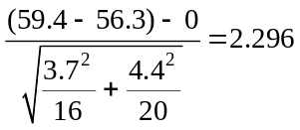
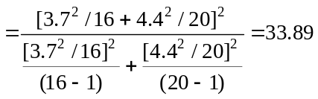
In the d.f. = 34 row of the t distribution table, the critical value for a right-tail test at the 0.05 level of significance is t = 1.691. The calculated t (2.296) exceeds 1.691, so we reject H₀ and conclude that speeds are faster on Monday than on Wednesday. Based on the t table alone, the p-value is between 0.025 and 0.01.
Given the summary data, we can also carry out this unequal-variances t-test using the Test Statistics workbook that accompanies Data Analysis Plus. Recall that it is first necessary to square the sample standard deviations (3.7 and 4.4) to obtain the sample variances (13.69 and 19.36). Based on the t table alone, the p-value is between 0.025 and 0.01. The exact p-value, shown in the printout below, is 0.0141.
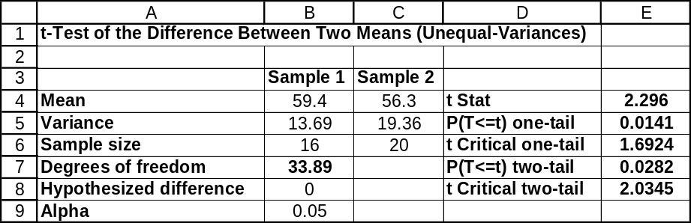

11.82 p/a/m The null and alternative hypotheses are:
H₀: μ_{d} ≤ 0 (the employee does not complete the test more quickly the second time)
H₁: μ_{d} > 0 (the employee does complete the test more quickly the second time)
For each person the difference is d = x₁ - x₂ ; with x₁ = time required to finish the first time, and x₂ = time required to finish the second time. After calculating the difference (d) for each employee,
The test statistic is: 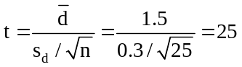
For a right-tail area of 0.05 and d.f. = (n - 1) = (25 - 1) = 24, the critical value is t = 1.711. The decision rule is: "Reject H₀ if the calculated t > 1.711, otherwise do not reject." Since the calculated test statistic falls in the rejection region, reject H₀. At the 0.05 level, we can conclude the average production employee will complete the test more quickly the second time he or she takes it.

11.83 p/a/m The null and alternative hypotheses are:
H₀: μ₁ = μ₂ , or μ₁ - μ₂ = 0 and H₁: μ₁ ≠ μ₂ , or μ₁ - μ₂ ≠ 0
Assuming σ₁ ≠ σ₂ , we will use the unequal-variances t-test and the computer. Hand calculations for the
t statistic and d.f. can be carried out as shown below.
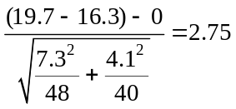
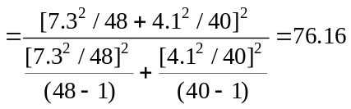
Using the d.f. = 76 row of the t distribution table, the critical values for a two-tail test at the 0.01 level are t = -2.642 and t = +2.642. The calculated t (2.75) exceeds the upper critical value, so we reject H₀ and conclude that the population means are not the same. Based on the t table alone, the
p-value is less than 0.01.

Given the summary data, we can carry out this unequal-variances t-test and generate the confidence interval using the Test Statistics and Estimators workbooks that accompany Data Analysis Plus. Recall that it is first necessary to square the sample standard deviations (7.3 and 4.1) to obtain the sample variances (53.29 and 16.81). The p-value (0.0075) is less than the 0.01 level of significance being used to reach a conclusion, so H₀ is rejected. For a true H₀, there is only a 0.0075 probability that this much of a difference between the sample means could occur by chance. The 99% confidence interval for (μ₁ - μ₂) is from 0.13 to 6.67 minutes. This interval does not include 0, so we conclude that (μ₁ - μ₂) is some value other than 0. The conclusion using the 99% confidence interval is consistent with the result of the two-tail hypothesis test at the 0.01 level of significance.
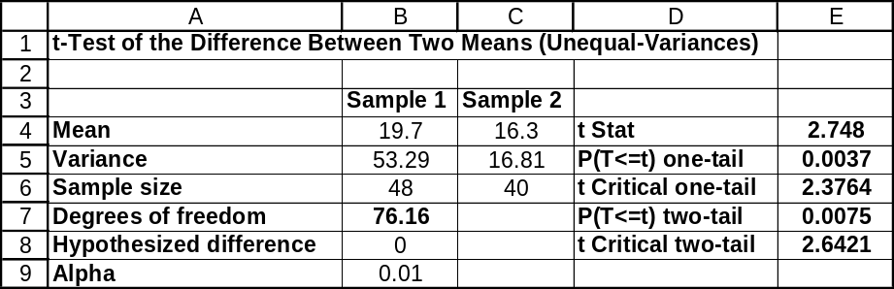

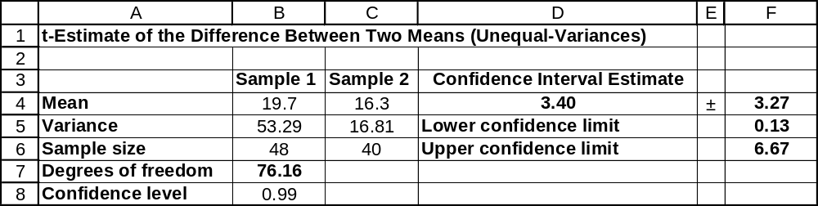

11.84 p/a/m The null and alternative hypotheses are:
H₀: μ₁ = μ₂ , or μ₁ - μ₂ = 0 and H₁: μ₁ ≠ μ₂ , or μ₁ - μ₂ ≠ 0
Assuming σ₁ ≠ σ₂ , we will use the unequal-variances t-test and the computer. Hand calculations for the
t statistic and d.f. can be carried out as shown below.
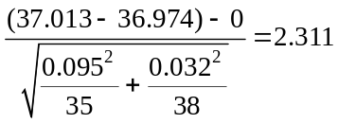
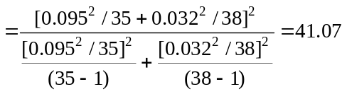
Using the d.f. = 41 row of the t distribution table, the critical values for a two-tail test at the 0.05 level are t = -2.020 and t = +2.020. The calculated t (2.311) exceeds the upper critical value, so we reject H₀ and conclude that the population means are not the same. Based on the t table alone, the p-value is between 0.05 and 0.02.

Given the summary data, we can carry out this unequal-variances t-test and generate the confidence interval using the Test Statistics and Estimators workbooks that accompany Data Analysis Plus. Recall that it is first necessary to square the sample standard deviations (0.095 and 0.032) to obtain the sample variances (0.009025 and 0.001024). The p-value (0.0259) is less than the 0.05 level of significance being used to reach a conclusion, so H₀ is rejected. For a true H₀, there is only a 0.0259 probability that this much of a difference between the sample means could occur by chance. The 95% confidence interval for (μ₁ - μ₂) is from 0.005 to 0.073 inches. By a slim margin, this interval does not include 0, so we conclude that (μ₁ - μ₂) is some value other than 0. The conclusion using the 95% confidence interval is consistent with the result of the two-tail hypothesis test at the 0.05 level of significance.
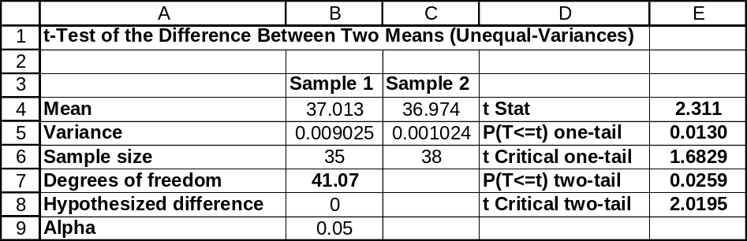

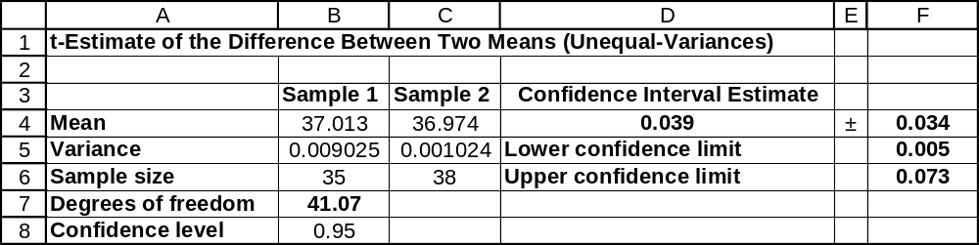

11.85 p/a/m The null and alternative hypotheses are:
H₀: μ₁ = μ₂ , or μ₁ - μ₂ = 0 (the average stay is the same at the two times)
H₁: μ₁ ≠ μ₂ , or μ₁ - μ₂ ≠ 0 (the average stay is not the same at the two times)
₁ and ₂ are the average stays in the store for the morning and afternoon customer samples.
Assuming σ₁ ≠ σ₂ , we will use the unequal-variances t-test and the computer. Hand calculations for the
t statistic and d.f. can be carried out as shown below.
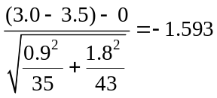
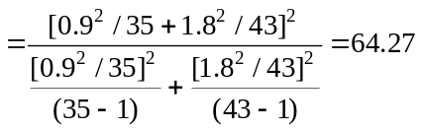
Using the d.f. = 64 row of the t distribution table, the critical values for a two-tail test at the 0.05 level are t = -1.998 and t = +1.998. The calculated t (-1.593) falls within these limits and we do not reject H₀.
We conclude that the population means could be equal. Based on the t table alone, the p-value is between 0.20 and 0.10.

Given the summary data, we can carry out this unequal-variances t-test and generate the confidence interval using the Test Statistics and Estimators workbooks that accompany Data Analysis Plus. Recall that it is first necessary to square the sample standard deviations (0.9 and 1.8) to obtain the sample variances (0.81 and 3.24). The p-value (0.1160) is not less than the 0.05 level of significance being used to reach a conclusion, so H₀ is not rejected. For a true H₀, there is a 0.1160 probability that this much of a difference between the sample means could occur by chance. The 95% confidence interval for (μ₁ - μ₂) is from -1.13 to 0.13 minutes. This interval includes 0, so we conclude that (μ₁ - μ₂) could be 0.
The conclusion using the 95% confidence interval is consistent with the result of the two-tail hypothesis test at the 0.05 level of significance.
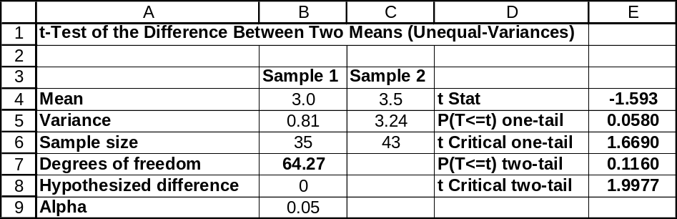

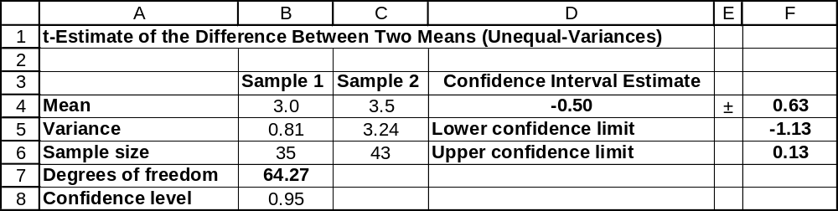

11.86 p/a/m Since the samples are dependent, we will use the t-test for paired observations.
The null and alternative hypotheses are:
H₀: μ_{d} ≤ 0 (the new ball does not increase the distance)
H₁: μ_{d} > 0 (the new ball does increase the distance)
For each golfer, d = x₁ - x₂, with x₁ = distance with the new ball, and x₂ = distance with the old ball.
The test statistic is: 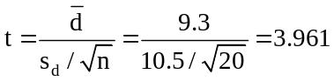
For a right-tail area of 0.005 and d.f. = (n - 1) = (20 - 1) = 19, the critical value is t = 2.861. The decision rule is: "Reject H₀ if the calculated t > 2.861, otherwise do not reject." Since the calculated test statistic falls in the rejection region, reject H₀. At the 0.005 level, we can conclude the new ball is effective in increasing the distance. Using the t table with d.f. = 19, p-value = P(t ≥ 3.961) is less than 0.005.

11.87 p/a/m Since the samples are dependent, we will use the t-test for paired observations.
The null and alternative hypotheses are:
H₀: μ_{d} ≤ 0 (the additive is not effective in increasing engine rpm)
H₁: μ_{d} > 0 (the additive is effective in increasing engine rpm)
For each generator, d = x₁ - x₂, with x₁ = speed of the engine with an oil additive, and x₂ = speed of the engine without an oil additive.
The test statistic is: 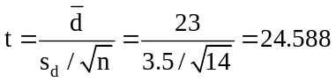
For a right-tail area of 0.05 and d.f. = (n - 1) = (14 - 1) = 13, the critical value is t = 1.771. The decision rule is: "Reject H₀ if the calculated t > 1.771, otherwise do not reject." Since the calculated test statistic falls in the rejection region, reject H₀. At the 0.05 level, we can conclude the additive is effective in increasing engine rpm.

11.88 p/a/m The null and alternative hypotheses are:
H₀: π₁ ≤ π₂ , or π₁ - π₂ ≤ 0 (the manager's idea is not effective)
H₁: π₁ > π₂ , or π₁ - π₂ > 0. (the manager's idea is effective)
p₁ and p₂ are the proportion of each sample who took at least one towel, those provided with white and green, respectively. The pooled estimate of the population proportions is:
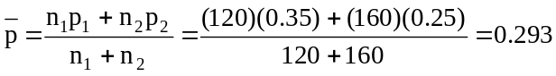
The test statistic is: 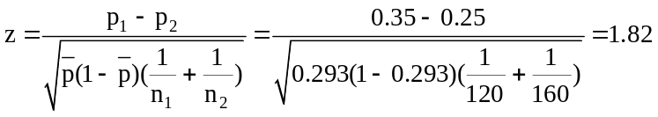

For a right-tail test at the 0.01 significance level, the critical value is z = 2.33. The decision rule is: "Reject H₀ if the calculated z > 2.33, otherwise do not reject." Since the calculated test statistic falls in the nonrejection region, do not reject H₀. At the 0.01 level, we cannot conclude that the manager's idea is effective in reducing the rate of towel theft. The observed difference between the groups' means is judged to have been due to chance.

Given the summary information in this exercise, the Test Statistics workbook provided with Data Analysis Plus was used for the printout below. In this right-tail test, the p-value (0.0344) is not less than 0.01, the level of significance used in reaching a conclusion, so we do not reject H₀. For a true H₀, there is a 0.0344 probability that p₁ could be this much larger than p₂ simply by chance.
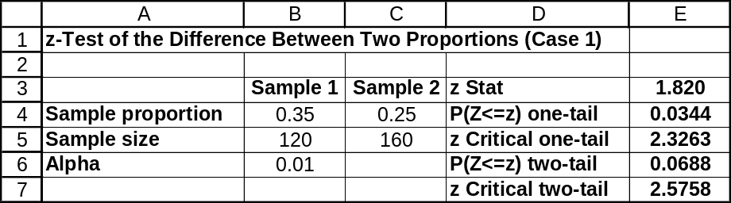

11.89 p/a/m The null and alternative hypotheses are:
H₀: π₁ ≤ π₂ , or π₁ - π₂ ≤ 0 (Ms. Smith is not a more effective auditor)
H₁: π₁ > π₂ , or π₁ - π₂ > 0. (Ms. Smith is a more effective auditor)
p₁ and p₂ are the proportion of each sample that had to pay additional taxes when audited by Ms. Smith and Mr. Burke. The pooled estimate of the population proportions is:
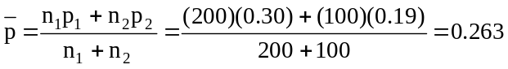
The test statistic is: 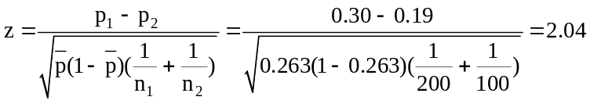
For a right-tail test at the 0.01 significance level, the critical value is z = 2.33. The decision rule is: "Reject H₀ if the calculated z > 2.33, otherwise do not reject." Since the calculated test statistic falls in the nonrejection region, do not reject H₀. At the 0.01 level, the manager cannot conclude that Ms. Smith is a more effective auditor than Mr. Burke. The observed difference between the auditors' means is judged to have been due to chance.

Given the summary information in this exercise, the Test Statistics workbook provided with Data Analysis Plus was used for the printout below. In this right-tail test, the p-value (0.0207) is not less than 0.01, the level of significance used in reaching a conclusion, so we do not reject H₀. For a true H₀, there is a 0.0207 probability that p₁ could be this much larger than p₂ simply by chance.
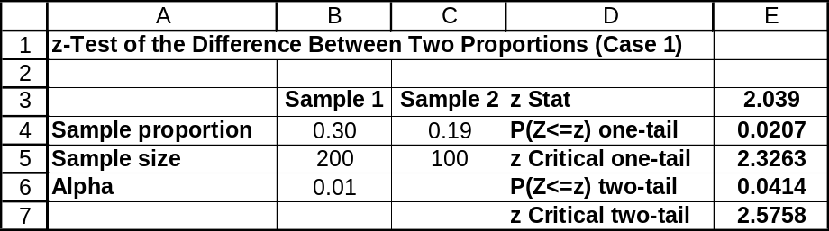

11.90 p/a/m The null and alternative hypotheses are:
H₀: π₁ ≥ π₂ , or π₁ - π₂ ≥ 0 (the new formula is not better than the old)
H₁: π₁ < π₂ , or π₁ - π₂ < 0. (the new formula is better than the old)
p₁ and p₂ are the proportion of each sample that reported "fast relief from headache pain" after taking old and new medications. The pooled estimate of the population proportions is:
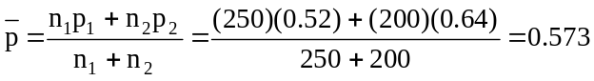
The test statistic is: 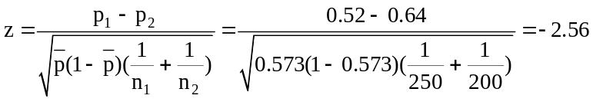
For a left-tail test at the 0.05 significance level, the critical value is z = -1.645. The decision rule is: "Reject H₀ if the calculated z < -1.645, otherwise do not reject." The calculated test statistic falls in the rejection region, so reject H₀. At the 0.05 level, we conclude that the new formula is better than the old. Using the standard normal table, p-value = P(z ≤ -2.56) = 0.0052.

Given the summary information in this exercise, the Test Statistics workbook provided with Data Analysis Plus was used for the printout below. In this left-tail test, the p-value (0.0053) is less than 0.05, the level of significance used in reaching a conclusion, so we reject H₀. For a true H₀, there is only a 0.0053 probability that p₁ could be this much smaller than p₂ simply by chance.
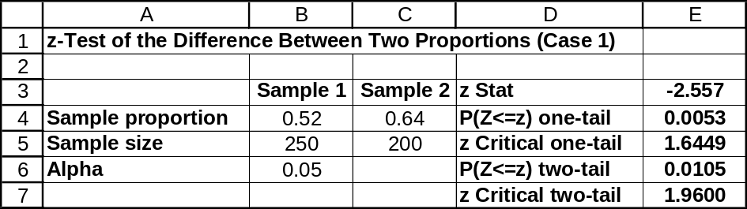

11.91 p/a/m Since the samples are dependent, we will use the t-test for paired observations.
The null and alternative hypotheses are:
H₀: μ_{d} ≤ 0 (the course is not effective)
H₁: μ_{d} > 0 (the course is effective)
For each subject, d = x₁ - x₂, with x₁ = words per minute after the course, and x₂ = words per minute before the course.
The test statistic is: 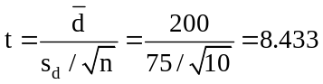
For a right-tail area of 0.10 and d.f. = (n - 1) = (10 - 1) = 9, the critical value is t = 1.383. The decision rule is: "Reject H₀ if the calculated t > 1.383, otherwise do not reject." Since the calculated test statistic falls in the rejection region, reject H₀. At the 0.10 level, the sample information suggests that the course is effective in improving students' reading speed. Using the t table with d.f. = 9, p-value = P(t ≥ 8.433) is less than 0.005.

11.92 p/a/m The null and alternative hypotheses are:
H₀: π₁ ≥ π₂ , or π₁ - π₂ ≥ 0 (the supplier's contention is not correct)
H₁: π₁ < π₂ , or π₁ - π₂ < 0. (the supplier's contention is correct)
p₁ and p₂ are the proportion of machines in each sample that are down for more than an hour while using the new and old lubricants. The pooled estimate of the population proportions is:
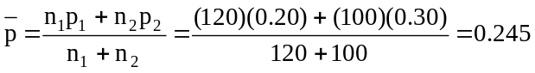
The test statistic is: 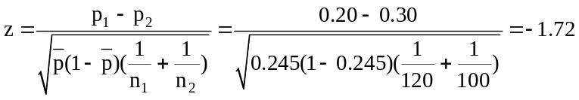
For a left-tail test at the 0.05 significance level, the critical value is z = -1.645. The decision rule is: "Reject H₀ if the calculated z < -1.645, otherwise do not reject." Since the calculated test statistic falls in the rejection region, reject H₀. At the 0.05 level, we can accept the supplier's contention that there will be less down-time for machines using the new lubricant.
Using the standard normal table, p-value = P(z ≤ -1.72) = 0.0427.

Given the summary information in this exercise, the Test Statistics workbook provided with Data Analysis Plus was used for the printout below. In this left-tail test, the p-value (0.0431) is less than 0.05, the level of significance used in reaching a conclusion, so we reject H₀. For a true H₀, there is a 0.0431 probability that p₁ could be this much smaller than p₂ simply by chance.
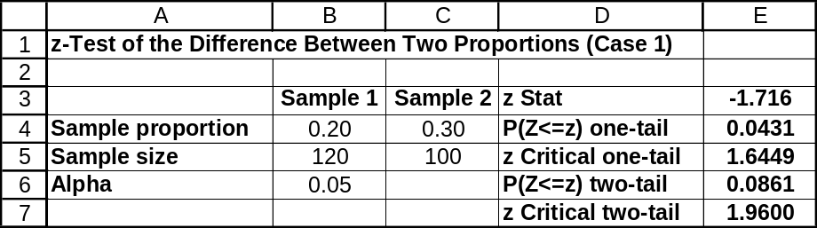

11.93 p/a/m The null and alternative hypotheses are:
H₀: π₁ ≤ π₂ , or π₁ - π₂ ≤ 0 (the higher-income proportion using a computer at school is no greater than
the lower-income proportion)
H₁: π₁ > π₂ , or π₁ - π₂ > 0 (the higher-income proportion using a computer at school is greater)
This exercise could be solved using formulas and pocket calculator, but we will use the Test Statistics workbook provided with Data Analysis Plus. In this right-tail test, the p-value (0.001) is less than 0.01, the level of significance used in reaching a conclusion, so we reject H₀. For a true H₀, there is only a 0.001 probability that p₁ would be this much larger than p₂ simply by chance.
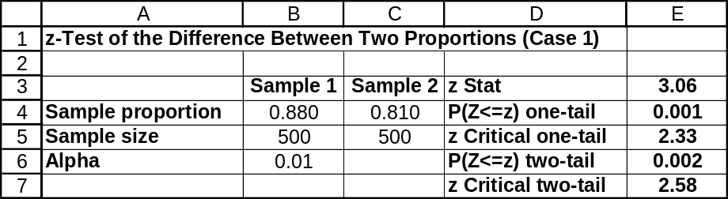

11.94 p/c/m The null and alternative hypotheses are:
H₀: π₁ = π₂ , or π₁ - π₂ = 0 (the proportions are the same in New Jersey and Tennessee)
H₁: π₁ ≠ π₂ , or π₁ - π₂ ≠ 0 (the proportions are not the same)

Given the summary data, we can carry out this z-test and generate the confidence interval using the
Test Statistics and Estimators workbooks that accompany Data Analysis Plus.
In this two-tail test, the p-value (0.079) is not less than 0.05, the level of significance used in reaching a conclusion, so we do not reject H₀. The population proportions could be equal. For a true H₀, there would be a 0.079 probability of obtaining this great a difference between the sample proportions by chance.
The 95% confidence interval for (π₁ - π₂) is from -0.010 to 0.190. Since zero is within the interval, we conclude that (π₁ - π₂) could be zero. This is the same conclusion reached in the hypothesis test.
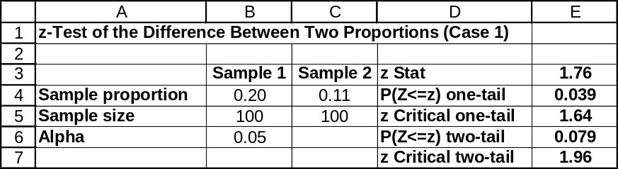

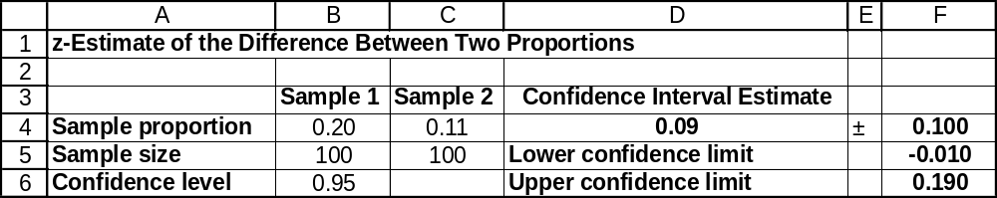

11.95 p/a/d In exercise 11.75, s₁² = 784, n₁ = 12, s₂² = 441, and n₂ = 9. A pocket calculator and formulas could be used, but we will use the computer. The null and alternative hypotheses are:
and
Since s₁ > s₂, the test statistic is: 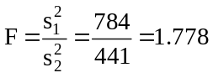, as shown in the first printout below.
The printouts below were generated using the Test Statistics workbook that accompanies Data Analysis Plus. Recall that it is first necessary to square the sample standard deviations to get the sample variances. For the two-tail test of whether the variances in exercise 11.75 could be equal, the p-value is 0.424, as shown in cell E6 of the first printout. This is not less than the 0.05 level of significance being used to reach a conclusion, so H₀ is not rejected. We were justified in assuming equal population variances. If the standard deviation for Emily had been $35, the test result would have been as shown in the second printout below and the two-tail p-value would have been 0.158. Again, the p-value is not less than the 0.05 level of significance and we would not reject H₀. The conclusion has not changed.
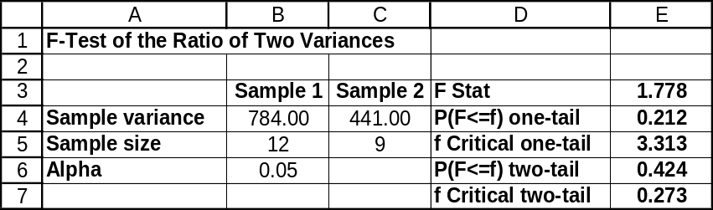

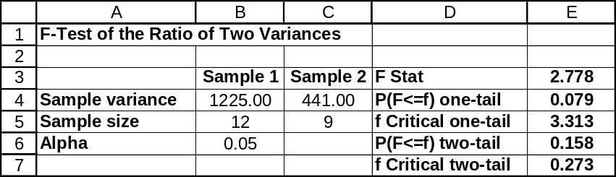

11.96 p/a/d In exercise 11.76, s₁² = 0.0009, n₁ = 8, s₂² = 0.0025, and n₂ = 10. A pocket calculator and formulas could be used for this exercise, but we will use the computer. The null and alternative hypotheses are:
and
Note: Because s₂ > s₁, if we were using a pocket calculator and the procedure described in the text, the test statistic would be calculated as 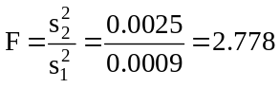. However, when we use the F-test in the Test Statistics workbook, there is no such need to designate the sample with the greater variance as sample 1. As a result, we will maintain the “sample 1” and “sample 2” designations used in the solution to the earlier exercise and the test statistic will be the inverse of the one shown above, or 1/2.778 = 0.360. This value is automatically calculated and displayed in the printout.

The first of the printouts below represents the two-tail test of whether the variances in exercise 11.76 could be equal, and the p-value is 0.192, as shown in cell E6. This is not less than the 0.01 level of significance being used to reach a conclusion, so H₀ is not rejected. We were justified in assuming equal population variances.
If the standard deviation for the rooftop carrier sample had been 0.07 gallons, the test result would have been as shown in the second printout below and the two-tail p-value would have been 0.036. Again, the p-value is not less than the 0.01 level of significance and we would not reject H₀. The conclusion has not changed.
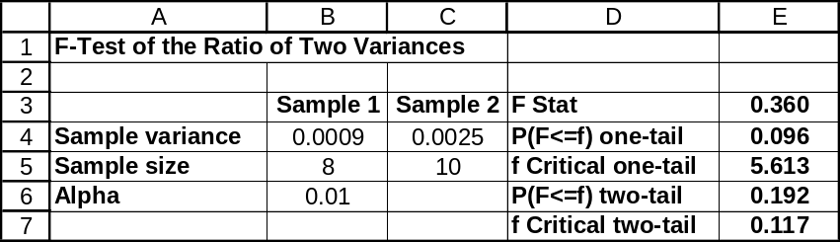

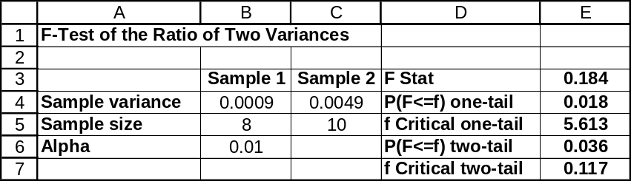

11.97 p/c/m The null and alternative hypotheses are:
H₀: μ₁ = μ₂ , or μ₁ - μ₂ = 0 and H₁: μ₁ ≠ μ₂ , or μ₁ - μ₂ ≠ 0
Assuming σ₁ ≠ σ₂, we use the unequal-variances t-test and Minitab. The printout is shown below.
For this two-tail test, the p-value (0.140) is not less than the 0.05 level of significance being used to reach a conclusion, so H₀ is not rejected. We conclude that the population mean salaries do not differ for graduates hired by consulting firms versus national-level corporations. For a true H₀, there is a 0.140 probability that this much of a difference between the sample means could occur by chance. The 95% confidence interval for (μ₁ - μ₂) is from -$1.95 thousand to +$12.96 thousand. This interval includes 0,
so we conclude that (μ₁ - μ₂) could be 0. The conclusion using the 95% confidence interval is consistent with the result of the two-tail hypothesis test at the 0.05 level of significance.

Two-Sample T-Test and CI: Consult, Corp

Two-sample T for Consult vs Corp

N Mean StDev SE Mean
Consult 15 64.31 9.16 2.4
Corp 12 58.80 9.41 2.7

Difference = mu Consult - mu Corp
Estimate for difference: 5.51
95% CI for difference: (-1.95, 12.96)
T-Test of difference = 0 (vs not =): T-Value = 1.53 P-Value = 0.140 DF = 23

11.98 p/c/m With sample 1 = “new system” and sample 2 = “standard system”, the null and alternative hypotheses are:
H₀: μ₁ ≥ μ₂ , or μ₁ - μ₂ ≥ 0 and H₁: μ₁ < μ₂ , or μ₁ - μ₂ < 0
Assuming σ₁ ≠ σ₂, we use the unequal-variances t-test and Minitab. The printout is shown below.
The p-value for this left-tail test is 0.141. This is not less than the 0.025 level of significance used to reach a conclusion, so H₀ is not rejected. We conclude that the mean bagging time for the new system might be at least as high as that for the standard system. For a true H₀, the probability is 0.141 that the sample mean for the new system could be this much lower than that for the standard system just by chance.

Two-Sample T-Test and CI: new, standard

Two-sample T for new vs standard

N Mean StDev SE Mean
new 18 9.30 1.50 0.35
standard 15 9.85 1.37 0.35

Difference = mu new - mu standard
Estimate for difference: -0.547
95% upper bound for difference: 0.302
T-Test of difference = 0 (vs <): T-Value = -1.09 P-Value = 0.141 DF = 30

11.99 p/c/m For each person, d = vertical leap with standard shoe - vertical leap with new shoe.
The null and alternative hypotheses are:
H₀: μ_{d} ≥ 0 (the new shoe is no better than the standard shoe)
H₁: μ_{d} < 0 (the new shoe is better)
The Minitab printout is shown below. For this left-tail test, the p-value (0.135) is not less than the 0.05 level of significance being used to reach a conclusion, so H₀ is not rejected. The new shoe may be no better than the standard model. For a true H₀, the probability is 0.135 of getting this large of a negative mean change in vertical leap height just by chance.

Paired T-Test and CI: HtCurrent, HtNew

Paired T for HtCurrent – HtNew

N Mean StDev SE Mean
HtCurrent 10 26.21 3.08 0.97
HtNew 10 26.63 3.71 1.17
Difference 10 -0.420 1.132 0.358

95% upper bound for mean difference: 0.236
T-Test of mean difference = 0 (vs < 0): T-Value = -1.17 P-Value = 0.135

11.100 p/c/d The null and alternative hypotheses are:
and
In using Excel in this two-tail test, we will specify the sample with the larger variance as sample number 1 (left column). In these data, the sample variance was higher for filler A. In the data file for this exercise, the data values for filler A are already on the left, so just specify this data field as sample 1. Although we are performing a two-tail test at the 0.01 level, specify 0.005 as the level of significance -- this is because Excel always assumes we are doing a one-tail test.

The Excel printout and a portion of its Minitab counterpart are shown below. The p-value for this two-tail test is 2(0.0894) = 0.1788, which is not less than the α = 0.01 level of significance on which we are basing our conclusion. At the 0.01 level, we do not reject H₀, and we conclude that the population variances (and, hence, standard deviations) could be equal for packages filled by the two machines.
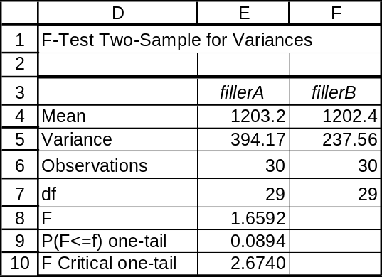

Test for Equal Variances

F-Test (normal distribution)

Test Statistic: 1.659
P-Value : 0.179

11.101 p/c/m The null and alternative hypotheses are:
H₀: π₁ = π₂ , or π₁ - π₂ = 0 (the population proportions for males and females are the same)
H₁: π₁ ≠ π₂ , or π₁ - π₂ ≠ 0 (the proportions are not the same)
Using Data Analysis Plus, we obtain the printouts below. In this two-tail test, the p-value (0.414) is not less than 0.10, the level of significance used in reaching a conclusion, so we do not reject H₀.
The population proportions could be equal. For a true H₀, there is a 0.414 probability of obtaining this great a difference between the sample proportions by chance. The 90% confidence interval for (π₁ - π₂) is from -0.1204 to 0.0404. Since zero is within the interval, we conclude that (π₁ - π₂) could be zero. This is the same conclusion reached in the hypothesis test.
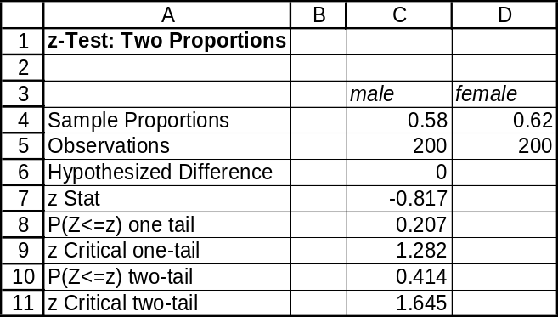

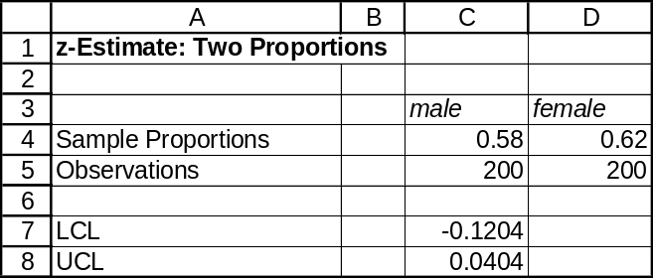

INTEGRATED CASES

THORNDIKE SPORTS EQUIPMENT

1. We will use Minitab and the unequal-variances t-test to examine whether the Thorndike goggles
might be of a better quality than the OptiView goggles. The null and alternative hypotheses are:
H₀: μ₁ ≤ μ₂ , or μ₁ - μ₂ ≤ 0 (Thorndike goggles are no better than OptiView)
H₁: μ₁ > μ₂ , or μ₁ - μ₂ > 0 (Thorndike goggles are better)

As shown in the Minitab printout below, the p-value for this test is 0.030. If the Thorndike goggles are really no better than their OptiView counterparts, there is only a 0.030 probability that Thorndike goggle test performance would be this much better than OptiView just by chance. Ted Thorndike would boast about the test results and ask the committee to switch to his company’s superior product.

Two-Sample T-Test and CI: Thorndk, OptiView

Two-sample T for Thorndk vs OptiView

N Mean StDev SE Mean
Thorndk 16 100.1 10.7 2.7
OptiView 16 91.6 13.5 3.4

Difference = mu Thorndk - mu OptiView
Estimate for difference: 8.44
95% lower bound for difference: 1.14
T-Test of difference = 0 (vs >): T-Value = 1.97 P-Value = 0.030 DF = 28

2. Optiview would want to say that the difference in the sample means is due to chance variation and they would prefer to use a numerically low level of significance, such as 0.01, in interpreting the findings. The printout p-value of 0.030 is not less than the 0.01 level of significance. Thus, if this level is used, H₀ will not be rejected, and the conclusion will be that Thorndike goggles are no better than OptiView. Accordingly, OptiView will argue that the U.S. Olympic team should stay with the goggles they have been using successfully for many years rather than taking a chance on another kind.

3. We would recommend that the committee switch to Thorndike goggles. If OptiView were just as good, the probability would be very slim (0.030) that Thorndike goggles could enjoy such a great test result advantage simply due to chance.

SPRINGDALE SHOPPING SURVEY

PART I: ATTITUDE COMPARISONS BASED ON MARITAL STATUS OF RESPONDENT

The Minitab printout below shows selected descriptive statistics for attitude toward each of the three shopping areas broken down by respondent marital status (1 = married, 2 = single or other):

Descriptive Statistics: SPRILIKE, DOWNLIKE, WESTLIKE by RESPMARI

Variable RESPMARI N Mean Median StDev
SPRILIKE 1 67 4.164 4.000 0.846
2 83 4.0241 4.0000 0.7153
DOWNLIKE 1 67 3.507 4.000 0.959
2 83 3.530 4.000 0.928
WESTLIKE 1 67 3.418 3.000 1.089
2 83 3.108 3.000 0.988

1. Unequal-variances t-test comparing married versus unmarried respondents’ attitudes toward Springdale Mall. As shown in the printout, the p-value is 0.282. If the two populations feel the same about Springdale Mall, there is a 0.282 probability that this much of a difference between the sample means could happen just by chance. If we use the 0.05 level of significance in reaching a conclusion, p-value = 0.282 is not less than 0.05, and we conclude the population means could be equal.

Two-Sample T-Test and CI: SPRILIKE, RESPMARI

Two-sample T for SPRILIKE

RESPMARI N Mean StDev SE Mean
1 67 4.164 0.846 0.10
2 83 4.024 0.715 0.079

Difference = mu (1) - mu (2)
Estimate for difference: 0.140
95% CI for difference: (-0.117, 0.397)
T-Test of difference = 0 (vs not =): T-Value = 1.08 P-Value = 0.282 DF = 129

2. Unequal-variances t-test comparing married versus unmarried respondents’ attitudes toward Downtown. As shown in the printout below, the p-value is 0.884. If the two populations feel the same about Downtown, there is a 0.884 probability that this much of a difference between the sample means could happen simply by chance. If we use the 0.05 level of significance in reaching a conclusion,
p-value = 0.884 is not less than 0.05, and we would conclude the population means could be equal.

Two-Sample T-Test and CI: DOWNLIKE, RESPMARI

Two-sample T for DOWNLIKE

RESPMARI N Mean StDev SE Mean
1 67 3.507 0.959 0.12
2 83 3.530 0.928 0.10

Difference = mu (1) - mu (2)
Estimate for difference: -0.023
95% CI for difference: (-0.330, 0.284)
T-Test of difference = 0 (vs not =): T-Value = -0.15 P-Value = 0.884 DF = 139

3. Unequal-variances t-test comparing married versus unmarried respondents’ attitudes toward West Mall. As shown in the printout below, the p-value is 0.074. If the two populations feel the same about West Mall, there is a 0.074 probability that this much of a difference between the sample means could happen simply by chance. If we use the 0.05 level of significance in reaching a conclusion, p-value = 0.074 is not less than 0.05, and we would conclude the population means could be equal. Of the three tests, this one is the most significant -- although it is not significant at the 0.05 level, it would be considered significant at a less demanding level, such as 0.10.

Two-Sample T-Test and CI: WESTLIKE, RESPMARI

Two-sample T for WESTLIKE

RESPMARI N Mean StDev SE Mean
1 67 3.42 1.09 0.13
2 83 3.108 0.988 0.11

Difference = mu (1) - mu (2)
Estimate for difference: 0.309
95% CI for difference: (-0.030, 0.649)
T-Test of difference = 0 (vs not =): T-Value = 1.80 P-Value = 0.074 DF = 134

4. For Springdale Mall and Downtown, married and unmarried respondents seem to feel nearly the same about these shopping areas. Married and unmarried respondents seem to differ with regard to how they feel about West Mall (married persons like it better), but the difference is of marginal significance.

PART II: ATTITUDE COMPARISONS BASED ON GENDER OF RESPONDENT

The Minitab printout below shows selected descriptive statistics for attitude toward each of the three shopping areas broken down by respondent gender (1 = male, 2 = female):

Descriptive Statistics: SPRILIKE, DOWNLIKE, WESTLIKE by RESPGEND

Variable RESPGEND N Mean Median StDev
SPRILIKE 1 58 4.0172 4.0000 0.7373
2 92 4.1304 4.0000 0.8013
DOWNLIKE 1 58 3.517 3.000 0.903
2 92 3.522 4.000 0.966
WESTLIKE 1 58 3.155 3.000 1.105
2 92 3.304 3.000 1.003

1. Unequal-variances t-test comparing male versus female respondents’ attitudes toward Springdale Mall. As shown in the printout below, the p-value is 0.378. If the two populations feel the same about Springdale Mall, there is a 0.378 probability that this much of a difference between the sample means could happen simply by chance. If we use the 0.05 level of significance in reaching a conclusion,
p-value = 0.378 is not less than 0.05, and we would conclude the population means could be equal.

Two-Sample T-Test and CI: SPRILIKE, RESPGEND

Two-sample T for SPRILIKE

RESPGEND N Mean StDev SE Mean
1 58 4.017 0.737 0.097
2 92 4.130 0.801 0.084

Difference = mu (1) - mu (2)
Estimate for difference: -0.113
95% CI for difference: (-0.366, 0.140)
T-Test of difference = 0 (vs not =): T-Value = -0.89 P-Value = 0.378 DF = 128

2. Unequal-variances t-test comparing male versus female respondents’ attitudes toward Downtown.
As shown in the printout below, the p-value is 0.977. If the two populations feel the same about Downtown, there is a 0.977 probability that this much of a difference between the sample means could happen simply by chance. If we use the 0.05 level of significance in reaching a conclusion, p-value = 0.977 is not less than 0.05, and we would conclude the population means could be equal.

Two-Sample T-Test and CI: DOWNLIKE, RESPGEND

Two-sample T for DOWNLIKE

RESPGEND N Mean StDev SE Mean
1 58 3.517 0.903 0.12
2 92 3.522 0.966 0.10

Difference = mu (1) - mu (2)
Estimate for difference: -0.004
95% CI for difference: (-0.312, 0.303)
T-Test of difference = 0 (vs not =): T-Value = -0.03 P-Value = 0.977 DF = 127

3. Unequal-variances t-test comparing male versus female respondents’ attitudes toward West Mall.
As shown in the printout below, the p-value is 0.406. If the two populations feel the same about West Mall, there is a 0.406 probability that this much of a difference between the sample means could happen simply by chance. If we use the 0.05 level of significance in reaching a conclusion, p-value = 0.406 is not less than 0.05, and we would conclude the population means could be equal.

Two-Sample T-Test and CI: WESTLIKE, RESPGEND

Two-sample T for WESTLIKE

RESPGEND N Mean StDev SE Mean
1 58 3.16 1.11 0.15
2 92 3.30 1.00 0.10

Difference = mu (1) - mu (2)
Estimate for difference: -0.149
95% CI for difference: (-0.504, 0.205)
T-Test of difference = 0 (vs not =): T-Value = -0.83 P-Value = 0.406 DF = 112

4. Regarding attitudes toward each of the three shopping areas, males and females could feel the same. There were no significant differences observed.

BUSINESS CASE

CIRCUIT SYSTEMS, INC. (A)

1. Because we are dealing with before and after measures for the same employees, we will use the dependent-samples t-test method. For each employee, the variable of interest will be absence days during the year before the program was implemented minus absence days during the year after the program was implemented. Because the intent of our test is to examine the effectiveness of the program in reducing absenteeism, this will be a one-tail test. The Minitab printout is shown below, and we will use the 0.05 level of significance in interpreting the results.

Paired T-Test and CI: Sick_LastYr, Sick_ThisYr

Paired T for Sick_LastYr - Sick_ThisYr

N Mean StDev SE Mean
Sick_LastYr 233 13.1609 5.0182 0.3288
Sick_ThisYr 233 8.6835 3.4199 0.2240
Difference 233 4.47747 2.89745 0.18982

95% lower bound for mean difference: 4.16399
T-Test of mean difference = 0 (vs > 0): T-Value = 23.59 P-Value = 0.000

The mean number of days absent is 4.47747 days less during the year following implementation of the program. The p-value for the test is extremely low, displayed here as 0.000, and this is < 0.05 level of significance for the test. On the basis of this test, the new program seems to be extremely effective in reducing employee absenteeism.

2. Keeping in mind that the goal of the program is to reduce the cost of absenteeism, we will now create two new variables for each employee:

Cost_Before = 8 * (Hourly Pay) * (Days Absent)

Cost_After = 8 * (Hourly Pay) * (Days Absent)
+ (18 - Days Absent)(8/3)(Hourly Pay) [this is the cost of unused paid sick leave]
+ (Exercise?)(200) [note that Exercise? is coded as 1 for those enrolled in the
exercise program, and 0 for those who are not, and the exercise program costs $200. So this component reflects
the cost of the exercise program.]

The Cost_Before and Cost_After values for the first six employees in the database are shown below:
Employee | Hourly_Pay | Sick_LastYr | Sick_ThisYr | Exercise? | Cost_Before | Cost_After
6631 | 10.97 | 3.50 | 2.00 | 0 | 307.16 | 643.57
7179 | 11.35 | 24.00 | 12.50 | 0 | 2179.20 | 1301.47
2304 | 10.75 | 18.00 | 12.75 | 0 | 1548.00 | 1247.00
9819 | 10.96 | 21.25 | 14.00 | 0 | 1863.20 | 1344.43
4479 | 10.59 | 16.50 | 11.75 | 0 | 1397.88 | 1171.96
1484 | 11.41 | 16.50 | 9.75 | 1 | 1506.12 | 1341.00

Using employee number 1484 as an example, his/her Cost_Before would be calculated as
8(11.41)(16.50) = $1506.12
Again using employ number 1484 as an example, his/her Cost_After would be calculated as
8(11.41)(9.75) + (18 - 9.75)(8/3)(11.41) + (1)(200) = $1341.00

For example, in Minitab, we can generate the Cost_Before values as follows: Click Edit, click
Command Line Editor, then enter let c6 = 8*c2*c3 into the box. Click Submit Commands.
In Minitab, we can generate the Cost_After values as follows: Click Edit, click Command Line Editor, then enter let c7 = (8*c2*c3) + ((18-c4)*(8/3)*c2) + (c5*200) into the box. Click Submit Commands.
Using these new variables in repeating the procedure followed in question 1 and using the 0.05 level of significance in reaching a conclusion, we obtain the Minitab results shown below:

Paired T-Test and CI: Cost_Before, Cost_After

Paired T for Cost_Before - Cost_After

N Mean StDev SE Mean
Cost_Before 233 1153.56 452.31 29.63
Cost_After 233 1095.32 220.48 14.44
Difference 233 58.2449 306.3989 20.0729

95% lower bound for mean difference: 25.0956
T-Test of mean difference = 0 (vs > 0): T-Value = 2.90 P-Value = 0.002

The mean cost of absenteeism is $58.2449 less during the year following implementation of the program. The p-value for the test is extremely low, displayed here as 0.002, and this is < 0.05 level of significance for the test. On the basis of this test, the new program also seems to be extremely effective in reducing the cost of employee absenteeism.

3. Using the new variables created in question 2, we will use this year’s costs and a two-sample t-test to evaluate the effectiveness of the exercise program. Because the intent is to examine the effectiveness of the program in reducing the cost of absenteeism, we will again use a one-tail test. The Minitab printout is shown below, and we will use the 0.05 level of significance in interpreting the results.

Two-Sample T-Test and CI: Cost_After, Exercise?

Two-sample T for Cost_After
SE
Exercise? N Mean StDev Mean
0 161 1053 213 17
1 72 1190 208 25

Difference = mu (0) - mu (1)
Estimate for difference: -136.809
95% lower bound for difference: -186.060
T-Test of difference = 0 (vs >): T-Value = -4.60 P-Value = 1.000 DF = 139

The mean cost of absenteeism this year is actually $136.809 higher for exercise program participants than for nonparticipants! For our right-tail test in which we were examining whether the exercise program might reduce the mean cost of absenteeism this year, the p-value is displayed as 1.000, which is certainly not < 0.05 level of significance for the test. As a matter of fact, a one-tail test in the other direction would show a p-value of 0.000 and lead to the conclusion that exercise program nonparticipants had a very significantly lower mean cost of absenteeism compared to those who participated in the exercise program. Naturally, part of the reason for the higher cost for exercise program participants is that the company is paying them $200 to be in the exercise program.

As a practical matter, our analysis indicates that the monetary costs of the exercise program exceed its monetary benefits. Based on these results, the exercise subsidization program should either be dropped or the amount of the subsidy reduced from the current $200. (Note: Some might argue that participation in the exercise program helps employee mental acuity, energy, and productivity on the job, but these are largely qualitative variables that we can not incorporate, as they lie beyond the information provided in our database.)

